Measuring household resilience with scalable machine learning models and artificial intelligence.

Outline for Operations Manual

**Executive Summary of the Outline Operations Manual**

|  |  |
| --- | --- |
| **Purpose** | *CRS has developed the Measuring Indicators for Resilience Analysis (MIRA) protocol to identify characteristics of resilient households and predict those most at risk. The protocol uses machine learning (ML) models and has been implemented in Malawi and Madagascar. To support scaling of MIRA to other countries, CRS received support to develop a ML model/platform. The purpose of this document is to help country programs use the ML model/platform; the manual should outline step by step all the things that need to happen to successfully run the model.* |
| **Target Audience** | *This manual is intended to be used by the CP MEAL/IT/Program staff who will be responsible for implementing, operating and maintaining the solution, GKIM/ICT4D Solution Engineers and the GKIM Data Scientist.* |
| **What support is expected from GKIM ICT4D Project Services and/or GKIM Data Scientist?** | *During deployment, the overall objective of this ICT4D Support is to assure the installation and deployment the package of this solution and assist the Project/Program to operate and explore this system,*  At this point,  *- assure that the copy of the digital data collection tools is in place to the new CommCare Project Space of the CP/Project*  *- work with the project manager to define and customize the Application based on the Project needs, and then assure all common data points for Measurement Indicators for Resilience Analysis are in place*  *- assure that MIRA Implementation Protocol (Data Collection-Data Exporting, Capacity Building, Data Quality Assurance – Data Use) is respected*  *- prepare the datasets will be used for the model Machine Learning*  *- provide the necessary guideline and assistance in implementing, setting Microsoft Azure Machine Learning Portal* |
| **Document revision history** | *The Revision history table shows the date, changes, and authors who have worked on this document* |

| Version/Change request number | Version date | Description of changes | Author |
| --- | --- | --- | --- |
|  | 12/03/2020 | First Draft |  |
|  | 12/18/2020 | Updated Version after Feedback |  |
|  | 21/01/2022 | Final Draft |  |

Contents

1. Background 3

2. Assumptions 3

3. What is MIRA? 3

Definition and Keys points 3

MIRA Summary 3

MIRA Protocol 4

MIRA Resilience 4

4. Digital data collection tools 5

Deployment process mapping 5

5. How to export data properly from CommCare 6

Export Form Data Settings 6

6. What is the purpose of the machine learning models? 7

Purpose of MIRA Machine Learning models 7

Which staff should be involved during development? 7

7. Artificial Intelligence - Machine Learning for MIRA 8

Overview 8

Machine Learning Approach 8

Business Process/outline 8

Azure Machine Learning Services 10

How to prepare/process the data 13

How to Upload data to Azure container 14

How to run ML model 15

How to develop reports/visualization 18

How to maintain the model 25

Scale-up Challenges: Madagascar MIRA dataset case study 25

# Background

Food insecurity has worsened by natural disasters, disease and conflict. In 2017, 821 million people faced starvation. Drought, floods and storms were responsible for 83, 17 and 23% of agricultural losses, respectively. Given that the average humanitarian crisis now lasts more than nine years, and that food security will remain a major concern due to climate-related threats, building resilient communities to withstand future shocks is essential (OCHA, 2019) and hence resilience strengthening is urgently needed. Measuring and predicting resilience is necessary for vulnerable communities and development actors to plan effective, tailored interventions.

In response to this need, CRS developed The Measurement Indicators for Resilience Analysis (MIRA) protocol in partnership with Cornell University to measure and predict an individual household’s ability to overcome current and future shocks. MIRA has four key phases: 1) Qualitative research and design of a digital data collection system, 2) Monthly data collection, 3) Data analysis & machine learning enabled forecasting and 4) Data validation through community engagement. MIRA has been implemented in Malawi and Madagascar for communities to use the information to prevent/prepare for future shocks. In Madagascar for example, MIRA data showed that ownership of chickens was a good predictor of increased food security and program staff used that information to encourage micro-savings groups to use resources for poultry raising.

To scale MIRA to new contexts, Microsoft supported CRS in studying the current MIRA ML model, developing a generic, scalable model that can used by different countries, providing standardization guidelines that allows for speedy implementation and developing a platform that allows country programs to more easily manage, process and analyze data, enabling the agency as a whole to assess the impact of our work and tell compelling stories.

This document dives into the details on how to successfully deploy the generic ML model developed, with the intent of operationalizing this to new countries/program areas.

As next steps, a few pilots needs to be done to deepen our understanding of the model while fine tuning this document.

# Assumptions

* To be truly generic, a level of standardization is required at the data point level, hence Malawi CommCare application and Data point serve as standard. (Further refinement can be done through pilot and implementations)

# What is MIRA?

## **Definition and Keys points**

*MIRA is Measurement Indicators for Resilience Analysis; it is a resilience measurement approach and tools that track household food security on a monthly basis, CRS considers MIRA as a stand-alone solution for measuring and predicting household resilience* *to inform program activities, targeting and adaptive management.*

*Resilience is* “*the capacity* *that ensures adverse shocks and stressors do not have persistent adverse consequences in terms of development outcomes” (Food Security Information Network, 2014)*

*Resilience is* “*the ability* *of people, households, communities, countries and systems (social, economic, ecological) to mitigate, adapt to, recover from shocks and stresses in a manner that reduces chronic vulnerability and facilitates inclusive growth” (USAID, 2012)*

## **MIRA Summary**

CRS is committed to building resilient communities and improving food security. Humanitarian aid and development actors have long recognized the value of resilience programming and the need for hyper-local data for understanding well-being dynamics. MIRA was developed as a solution to this need by the monitoring, evaluation, accountability and learning unit (MEAL) of CRS and the Charles H. Dyson School of Applied Economics and Management at Cornell University. MIRA was first trialed in 2016 for the Malawi USAID FFP DFAP and has since been used to measure and improve resilience and food security for over 2,700 households. MIRA has also been recognized as an effective tool by local leaders, village development committees, governments, donor agencies and implementing partners.

The Measurement Indicators for Resilience Analysis (MIRA) measures and predicts an individual household’s ability to overcome current and future shocks. Using MIRA, village development committees and community members can monitor the experience and persistence of shocks, understand how household characteristics affect resilience and strengthen community-level early warning systems. MIRA allows for adaptive management by using hyper-local, up-to-date information to inform targeting, activity selection and continued improvement of project design. Developed by CRS and Cornell University, MIRA has supported over 2,700 households and empowered communities to use data to mitigate the negative impact of shocks such as drought, flooding, crop disease and illness. The direct community engagement distinguishes MIRA from other approaches in that it is a two-way feedback mechanism where project participants can provide input, receive up-to-date information on community-level impact and use the data to advocate for interventions that improve resilience. Moreover, the frequency of data collection and analysis (monthly) is another differentiating factor from other resilience monitoring approaches (typically annual), allowing for more accurate data around specific shocks and more timely response. When compared to other tools, MIRA has shown to be a low-cost method, making it a more sustainable choice for adoption

## **MIRA Protocol**

During the Implementation, MIRA adopts the following phases

* Qualitative research and design of a digital data collection system,
* Monthly data collection on shocks and stresses, food security and coping strategies
* Data analysis & machine learning enabled forecasting and
* Data validation through community engagement.

The digital data collection system consists of a baseline survey with comprehensive information on household characteristics such as livelihood activities, assets (amount of land farmed, livestock owned, second house/shed), geo-location (living inside or outside a flood plain), information on head of household (age, gender, education), household members recorded as chronically ill or disabled, and shock history. The system also includes a monthly survey used to track persistence of shocks and food security indicators. Using a CommCare mobile application, enumerators collect the baseline and monthly household data, generating a large dataset from which to draw and understand patterns among food secure and insecure households. *With machine learning and predictive analytics, MIRA identifies characteristics that make a household resilient and predicts households most vulnerable to shocks one to two months in advance*. Results are shared with village development committees and local leaders, community members, governments and implementing partners to facilitate decision-making and response activities.

## **MIRA Resilience**

Resilience is captured by a set of capacities that enable households and communities to effectively function in the face of shocks and stresses and still meet a set of well-being outcomes. The ability to measure resilience involves measuring the relationship between shocks, capacities, responses, and current and future states of well-being. Thus, there is no single indicator that measures resilience. There is a need for a few indicators to be analytically used as part of a measurement framework. There are four key factors to consider in measuring resilience:

* Identify the well-being outcomes (e.g. food security indicators) to be achieved and measure resilience in relation to these outcomes.
* Identify the shocks and stresses that individuals, households, communities and systems are exposed to and the severity and duration of these shocks and stresses (Shock experienced that have adverse effects).
* Measure the absorptive, adaptive and transformative capacities in relation to these shocks and stresses at different levels (Capacities and characteristics that may prevent adverse effects and/or enable recovery).
* Identify the responses of individuals, households, communities and systems to these shocks and stresses and trajectory of well-being outcomes.

To quantify the food security metric and resilience, four standard scores, proposed by the relevant literature, have been computed for the analysis. These scores include reduced coping strategy index (rCSI), household hunger scale (HHS), household diet diversity scale (HDDS), and food consumption score (FCS). rCSI and HHS scores are computed using the high-frequency panel data and HDDS and FCS are computed based on annual data.

|  |  |  |
| --- | --- | --- |
| **Indicator** | **Description** | **Source** |
| Reduced Coping Strategies Index (**rCSI**) | Sum of 5 less-severe coping strategies (related to borrowing, reducing meals/portions, and eating less preferred foods), weighted by severity and by days used in past 7 | Maxwell & Caldwell (2008), USAID |
| Household Hunger Scale (**HHS**) | Sum of resort to 3 severe coping strategies (no foods in the household; days going to bed hungry; days without eating), weighted by frequency in past 30 days | Ballard et al. (2011), USAID/FANTA - III |
| Household Dietary Diversity Score (**HDDS**) | Sum of 11 food groups (un-weighted, 14- hour recall) | Swindale & Bilinsky (2006), USAID/FANTA |
| Food Consumption Score (**FCS**) | Weighted sum of 8 food groups, weighted by quality and multiplied by frequency consumed (days in past 7) | Weisman et al. (2009), WFP/VAM |

# Digital data collection tools

MIRA Project in Malawi uses the CommCare Platform to design the Mobile Data collection tools in this Project Space <https://www.commcarehq.org/a/crs-malawi/dashboard/project/>, we suggest the CP/project who wants to apply this App to follow this below process

## **Deployment process mapping**

This is the simple process on how to deploy this Digital Data Collection Tools for MIRA at the CP/Project

1. At CP/Project level, it is mandatory to have a new or existing CommCare Project Space that will be used to install this application, if the project wants to get a new one, fill in the request-form [here](https://crsprod.service-now.com/nav_to.do?uri=%2Fcom.glideapp.servicecatalog_category_view.do%3Fv%3D1%26sysparm_parent%3D578a0c00db1bd700bb3f400e0b9619d7%26sysparm_ck%3D256b35aadbc9e3c005ff164948961978cbb8e8a0431ae0ca0c8c37bcab9a61df85da39a5%26sysparm_catalog%3De0d08b13c3330100c8b837659bba8fb4%26sysparm_catalog_view%3Dcatalog_default) and ask Service Desk to create it, if the project space was already available, it is a decision for the CP/Project to reuse it or not.
2. For the new CommCare Project Space, with this request-form, provide or mention the label or name of this new Project Space as **REGION|CP| MIRA**
3. Make sure with GSD that your role in this project space is a Project Administrator. In case you are invited by the project manager to access this new project space, please ask GSD to access it with the roles of project administrator, submit your request [here](https://crsprod.service-now.com/nav_to.do?uri=%2Fcom.glideapp.servicecatalog_cat_item_view.do%3Fv%3D1%26sysparm_id%3D4ec4d7fedbaad7000adae536ca961920%26sysparm_link_parent%3D578a0c00db1bd700bb3f400e0b9619d7%26sysparm_catalog%3De0d08b13c3330100c8b837659bba8fb4%26sysparm_catalog_view%3Dcatalog_default) in mentioning that you are requesting multiple web user accounts and then fill the attached file in question
4. Ask GSD to copy the Application **CRS Malawi MIRA** from the project space source **crs-malawi** to the new project space of CP/Project.
5. When the copy is done, verify in your project space, so

* You have four mains modules and several forms

|  |  |  |
| --- | --- | --- |
| **Module** | **Form** | **Type** |
| Household Register | Register HH | Registration Form |
| High Frequency Survey | High Frequency Survey | Follow-up Form |
| Baseline/Endline Survey | 1. Consent | Follow-up Form |
| 2. Demographics | Follow-up Form |
| 3. Livelihood | Follow-up Form |
| 4. Assets | Follow-up Form |
| 5. Wellbeing | Follow-up Form |
| 6. Assistance | Follow-up Form |
| 7. Social Networks | Follow-up Form |
| 8. Shock History | Follow-up Form |
| 9. High Frequency | Follow-up Form |
| COVID | Covid-19 | Follow-up Form |

* If the Lookup Table is uploaded on this Application, if it is not there asking GSD to copy it

1. Change the name of the application as **ProjectName-MIRA**
2. Customize the Lookup Table

* From the new Project Space, download the default Lookup Table, (this file includes the tables of the **administrative_boundary** (District, TA, GHV, Village) in Malawi and the **crops**)
* Working with the Project Manager to update (or change) the default list of the Administrative in putting the real list of Administrative used for CP/Project.
* Upload the updated Lookup Table and **Replace existing tables**

1. During the customization on this application you can modify or change only the LABEL (**Display Text**) for each data point (or question) but NEVER CHANGE **the structure of this Application, the Question ID,** **type of variable** (1 Number – T text) and **case properties,** in case any Field/Group/Section is not required, **hide it** but **Do Not Delete**
2. Test the new Application with the Users (Mobile Workers), at this point create the login (username & Password) for testing

* For Malawi the *User Property* is designed on the application source, so if the CP/Project does not apply this Settings, please remove the Filter on *Display Condition* for each Module, if not refer this attached file to get this structure on User Property
* After testing you can delete the collected data by those Mobile Workers by deleting directly their Username

User property

 

This is the reference for this lookup table 

# How to export data properly from CommCare

## **Export Form Data Settings**

On this step we need to export the collected data from each form in CommCare via Export Form Data, sure we can apply the other process to export data, but we will only use for this deployment the export feature on **Export Form Data**

Be careful, **this step should be executed only when all the application customization has been done.**

1. Working with the new application, start to **Add Export** for each form on using the **Export Form Data**
2. Set up the Export Data from each individual Form
3. **Export Settings**, on this stage so we start to set up this export (start to structure the data source table from this export) by providing

* the Name of this Export (Export Name)
* the name of the Table from the Form
* the name of Column from the field (data point), please refer this setting to Malawi Variable (data point) dictionary

1. To finalize this process, click on Create button to save and exit this Data Export setting

This is the reference for variable dictionary from Malawi



# What is the purpose of the machine learning models?

## **Purpose of MIRA Machine Learning models**

Microsoft AI for Humanitarian Action program is supporting CRS to scale the ML model, the main purpose for this engagement is to operationalize the analytical component of MIRA by establishing a scalable tool/platform/model for using AI-Machine Learning for good. So, the specifics objectives for this operationalization are

* Develop a generic scalable machine learning algorithm and package these models for use by more CRS projects
* Create platform and provide tools to develop and tune models for new locations (new MIRA project in another CRS Country Program)
* Integrate data visualization tools

## **Which staff should be involved during development?**

Microsoft data science team supports the CRS Team in developing and implementing the ML models for MIRA under the Microsoft Azure Machine Learning service, for this case the MS team provides to CRS Team the guideline and assistance to set up the Azure ML environment. To assure, so this assistance was working well, and the settings were completely done, GKIM team suggests and assigns the following staff with roles and responsibilities to assure these tasks with MS Team, this is not the exhaustive list of CRS Staff who should be involved during the development and the deployment for new MIRA project.

|  |  |
| --- | --- |
| Role | Key Responsibilities |
| Regional ICT4D Solution Engineer | * Understanding machine learning and being able to talk through the MIRA approach. * Setting up Commcare forms. * Gathering data and exporting.   *Solution Engineer works closely with CRS Regional MEAL Technical Advisor and/or Project MEAL Manager to prepare the Data Export Query from the data source platform as Commcare, also working with the Data Scientist to prepare, clean and provide the Dataset of MIRA For the deployment, Solution Engineer with Azure capabilities will assure the settings of Azure ML portal, will support the CP/Project in transferring the codes to this environment* |
| GKIM Data Scientist | * Responsible for maintaining machine learning environment. * Responsible for running models with data from SE. * Responsible for modifying models based on feedback from SMEs.   *The Data Scientist will support MEAL staff to prepare the MIRA dataset that should be used for the data Processing Codes.*  *The Data Scientist will always configure (customize) the machine learning models.*  *The Data Scientist will be responsible for maintaining and running the Machine Learning Pipeline and developing data visualization dashboards. The Data Scientist with Machine Learning experience, who will take over the solution from Microsoft and will also transition over the knowledge to other CRS staff. (develop the project staff’s capacity to run the model while providing just backstopping support)*  *For the sustainability Data Scientist who would maintain and manage this package going forward.* |

# Artificial Intelligence - Machine Learning for MIRA

## **Overview**

Based on MIRA Dataset for Malawi, MS Team developed the ML models using Python programming language. While the data processing step will need modifications for each new country, the ML component is re-useable for any new locations/properly processed datasets. The Microsoft data science team pursued the path to develop models that are supported sufficiently by data science “research” and extensive empirical analysis. To have enough flexibility and not get locked by limited functionality of the built-in platforms such as drag & drop Machine Learning Studio built-in services, the MS Team normally develops Python scripts from scratch, deploy and apply these models under the Azure Machine Learning Service (Azure ML) as the computing platform. However, the ML pipeline can be used on any other computing platforms with minor changes. The Azure Machine Learning Service provides tools to scale and automate training, deployment and monitoring of machine learning model training and experiments easily. To conduct model training on Azure, the Azure Portal of CRS’s subscription should be set up accordingly for experimentation. MS Team supported CRS Team to create and set up the Machine learning experiments into Azure Portal by creating the new ML Workspace, adding the Storage account, setting the GPU for the Virtual machine, initializing an Experiment. Figure 1 demonstrate the machine learning workflow designed to use MIRA dataset to derive insights for informed decision making. For further details about the ML model and analysis please see the slides [here](https://crsorg.sharepoint.com/:f:/r/sites/TM-Microsoft-AI/Shared%20Documents/General/MS%20Deliverables?csf=1&web=1&e=es4d7q).

To operationalize this ML pipeline, CRS might need to regularly update the datasets and retrain their models parameters. For some countries, the data collection activity might be an ongoing process. As such, CRS may want to update the model parameters every once in a while, (e.g., monthly or every two months) based on the most up-to-date dataset that has been collected. So processing the most recent dataset and running the model to retrain the parameters based on the most up-to-date dataset for each country should be considered as a routine task for the person who is in charge of this project at CRS.

## **Machine Learning Approach**

The processing step should be conducted via some separate steps for both cross-sectional-data and time-series assumptions. In particular, for the time-series assumption, deep learning time-series classification methods are available. Additionally, for both time-series style dataset and cross-sectional style dataset, classical machine learning models including the [randomforest] (<https://dev.azure.com/dsnaexternal/_git/Catholic%20Relief%20Services?path=%2Fclassifiers%2Frandomforest.py&version=GBmaster> ) and [logisticregression] (<https://dev.azure.com/dsnaexternal/_git/Catholic%20Relief%20Services?path=%2Fclassifiers%2Flogisticregression.py&version=GBmaster> ) models are also available. To analyze the interpretability of the models, the SHAP library has also is used in this repository.

To learn about details of the deep learning methods used in this repository see [this review paper] (<https://link.springer.com/article/10.1007%2Fs10618-019-00619-1> ) titled "Deep learning for time series classification: a review" published in [Data Mining and Knowledge Discovery] (<https://link.springer.com/journal/10618> ), also available on [ArXiv] (<https://arxiv.org/pdf/1809.04356.pdf> ).

## **Business Process/outline**

* The Data is collected via door-to-door Survey collection. It is then exported from the CommCare.
* The country program data is preprocessed, analyzed and machine learning models are developed.
* The model is hosted on Azure Environment so that it can use the cloud resources to run.
* The results are interpreted by the domain expert and used for making better business decisions.

*The CRS domain experts should do their due diligence to make sure the AI results make sense for future decision making in the field. What MS has developed is a decision aid tool and requires human expert supervision for final operationalization.*

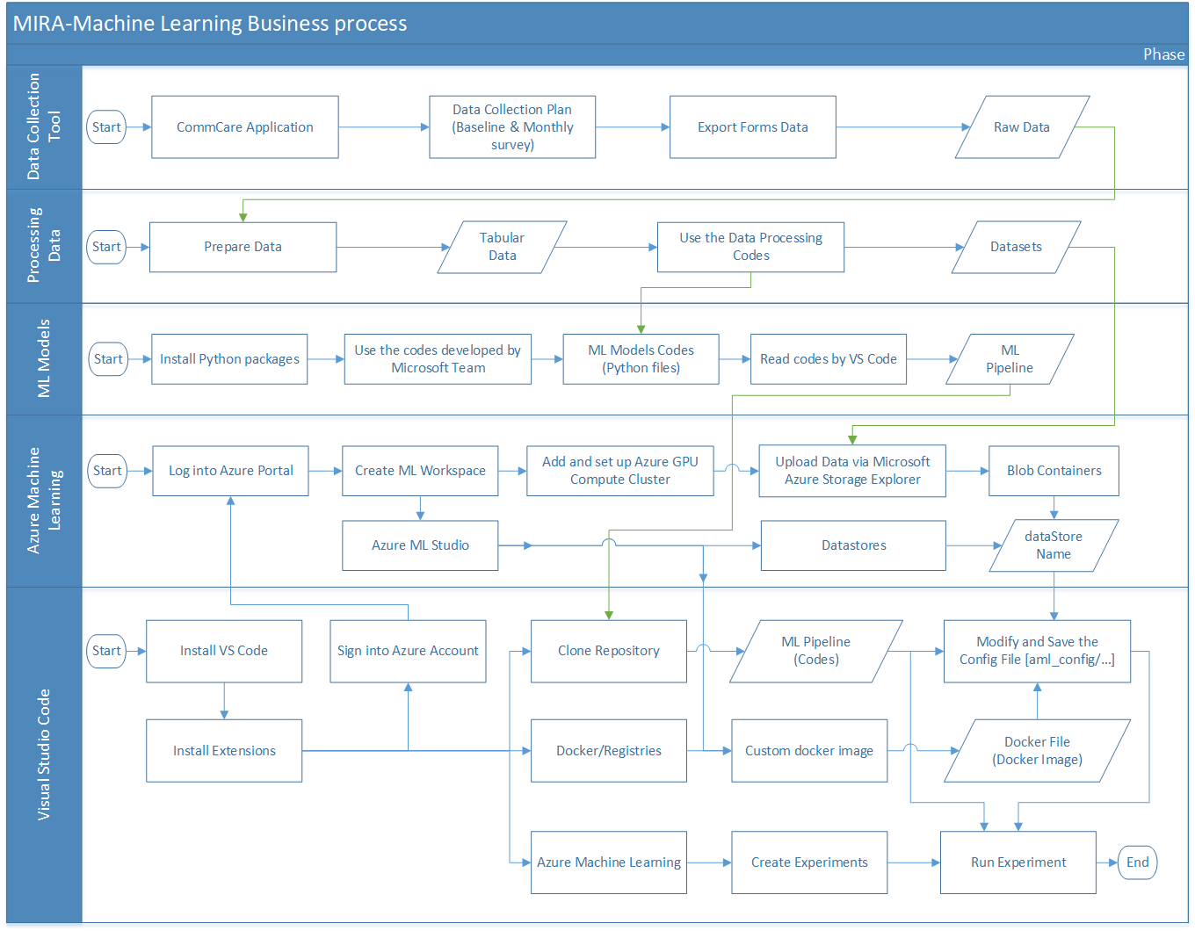

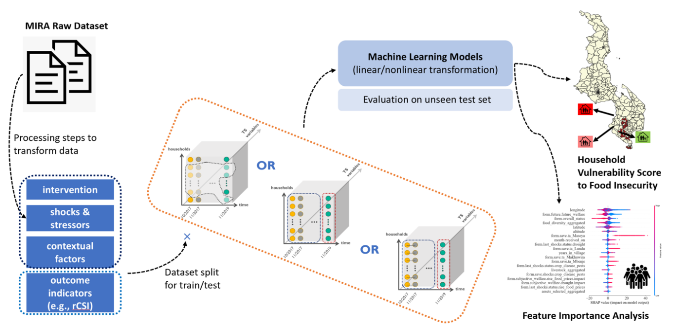

Figure 1 Machine Learning Solution Pipeline: from the Input MIRA Dataset to Outputs

## **Azure Machine Learning Services**

1. Create an Azure Machine Learning Workspace

With Azure Portal using an account with a valid subscription, you can create, view and delete Azure ML workspaces. The workspace is the top-level resource for Azure ML, providing a centralized place to work with all the artifacts you create when you use Azure ML. The workspace keeps a history of all training runs, including logs, metrics, output, and a snapshot of your scripts.

**Workspace High-level Architecture**

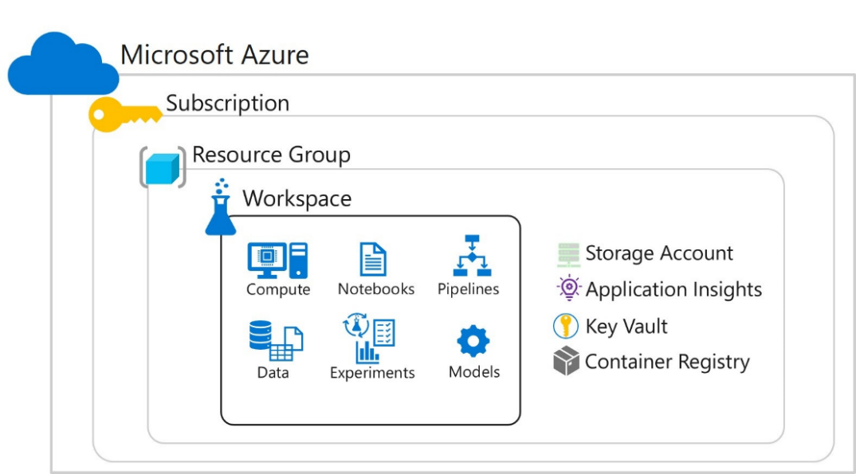

<https://docs.microsoft.com/en-us/learn/modules/intro-to-azure-machine-learning-service/2-azure-ml-workspace>

**Workspace Settings**

This is a simple process to create a new Azure ML workspace in your subscription

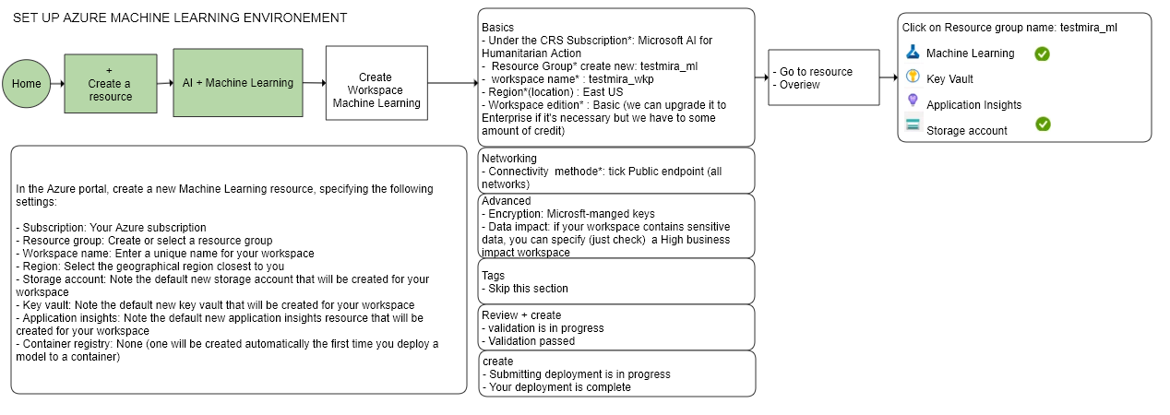



Also, provide the following information to configure your new workspace

|  |  |
| --- | --- |
| Field | Description |
| Workspace name | Enter a unique name that identifies your workspace. Names must be unique across the resource group. Use a name that's easy to recall and to differentiate from workspaces created by others. The workspace name is case-insensitive.  *Workspace name must be between 2 and 32 characters of letters and numbers.* |
| Subscription | Select the Azure subscription ID that you want to use.  *The parameter is required if the user has access to more than one subscription.* |
| Resource group | Use an existing resource group in your subscription or enter a name to create a new resource group. A resource group holds related resources for an Azure solution. *You need contributor or owner role to use an existing resource group*. |
| Region (location) | Select the Azure region closest to your users and the data resources to create your workspace.  *The location has to be a supported region for Azure Machine Learning Services.* |

<https://microsoftlearning.github.io/mslearn-dp100/>

**Workspace Associated resources**

When you create a new workspace, it automatically creates several Azure resources that are used by the workspace.

|  |  |
| --- | --- |
| Key Vault | The Azure Key Vault will be used by the workspace to store credentials added to the workspace by the users. By default, If NULL a new key vault will be created.  *used to manage secrets such as authentication keys and credentials used by the workspace.* |
| Application Insights | The Application Insights will be used by the workspace to log webservices events. By default, a new one is created.  *Used to monitor predictive services in the workspace (stores monitoring information about your models).* |
| Container Registry | The Azure Container Registry will be used by the workspace to pull and push both experimentation and webservices images. It is not initially created for the workspace. Instead, *it is created once you need it when creating a Docker image during training or deployment.* |
| Storage account | The storage will be used by the workspace to save run outputs, code, logs etc. If NULL a new storage will be created. *Used to store files used by the workspace as well as data for experiments and model training.* |

**Workspace Low-level Architecture**

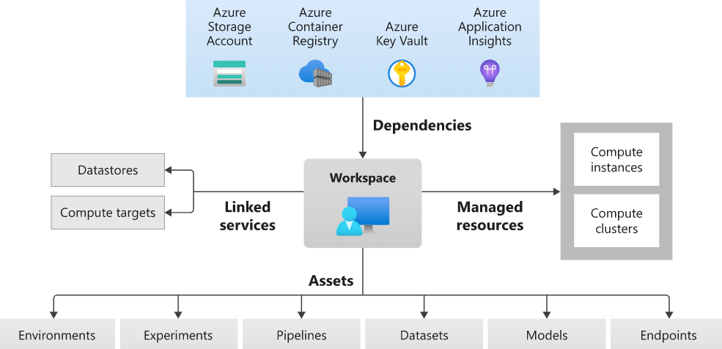

<https://docs.microsoft.com/en-us/azure/machine-learning/concept-azure-machine-learning-architecture>

When the Azure Machine Learning Workspace is created, Launch studio to access in your Microsoft Azure Machine Learning platform

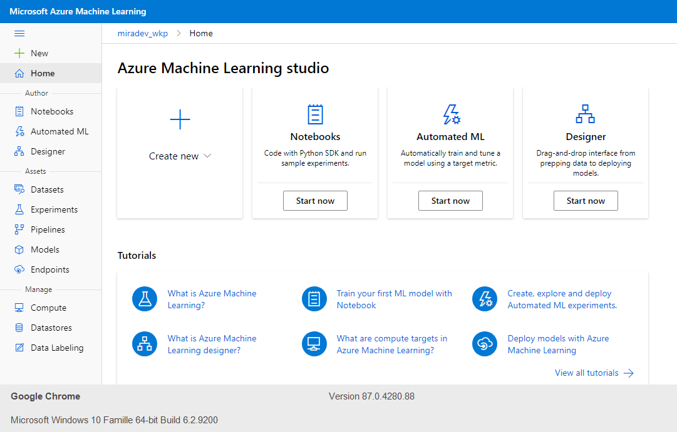

The Azure Machine Learning is the centralized place to:

1. Manage resources you use for training and deployment of models, such as computes
2. Store assets you create when you use Azure Machine Learning, including:

* Environments
* Experiments
* Pipelines
* Datasets
* Models
* Endpoints

1. Create Azure Machine Learning Compute Cluster

With Microsoft Azure Machine Learning:

1. Click on **Compute**
2. Move on tab **Compute clusters** and **Create** a new cluster
3. Set up the Virtual Machine

* Region: **eastus**
* Virtual machine: **GPU**
* Virtual machine size: **Standard_NC6** (6 cores, 56GB RAM, 380GB storage)
* Cluster name: exp **miradev-cluster**
* Minimum number of nodes: 0
* Maximum number of nodes: 3
* Idle seconds before scale down: 120

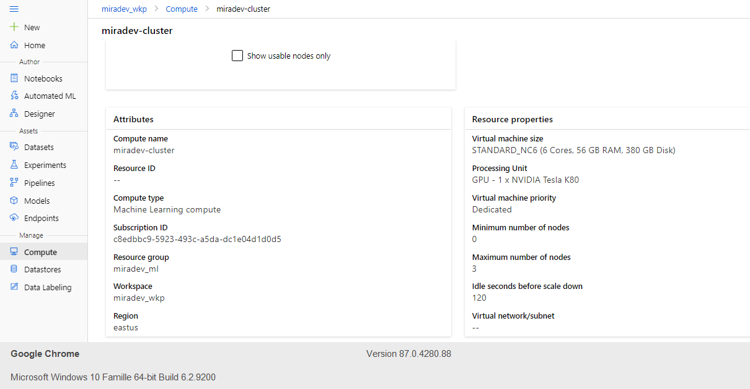

General documentation on Azure ML can be found here for reference:

* <https://docs.microsoft.com/en-us/azure/machine-learning/>
* <https://docs.microsoft.com/en-us/azure/machine-learning/how-to-create-attach-compute-cluster?tabs=python>

## **How to prepare/process the data**

The Malawi datasets are shared [here](https://teams.microsoft.com/_#/files/MIRA%20DATA%20and%20guidance?threadId=19%3Aea38313900344711a50dba00d1bebb05%40thread.skype&ctx=channel&context=Malawi&rootfolder=%252Fsites%252FTM-Microsoft-AI%252FShared%2520Documents%252FMIRA%2520DATA%2520and%2520guidance%252FMalawi). Datasets are collected on monthly and Annual basis.

There would be two excel files available:

1. High Frequency Dataset
2. Annual Dataset – It will have multiple work sheets each representing one module. Sometimes the modules would be exported in different excel files.

Best Practice: Please save all the modules in the same excel file as separate worksheets.

**Data Preprocessing Codes**

Please note that we have 5 scripts for data processing: The scripts are available [here](https://dev.azure.com/dsnaexternal/_git/Catholic%20Relief%20Services?version=GBmaster&path=%2Fdata).

1. **data/1-high-frequency-data-wrangling.py à**Developed to process high frequency MIRA datasets. To test this script please start with a file named “High Frequency Survey (FAW).xlsx” and modify the input directory path for this xlsx file in the script. The script creates a folder named “1-high-freq-panel-data-processed” inside input directory where all of the intermediary results are stored The major intermediary steps for processing are marked by comments in the script to give you hints (look for this sign in the main function: #========).



1. **data/2-annual-data-wrangling.py à**Developed to process annual survey dataset. To test this script please start with a file named “Baseline-Endline.xlsx” and modify the input directory path for this xlsx file in the script. The script creates a folder named “1-annual-panel-data-processed” inside input directory where all of the intermediary results are stored. The major intermediary steps for processing are marked by comments in the script to give you hints (look for this sign in the main function: #========).



1. **data/3-combine_high_freq_annual_data à**Developed to merge high freq. and annual processed data from step 1 & 2. It also computes food security metrics and adds those columns to the dataset for further use in ML pipeline. Please note that in all these steps you will see vertical and panel data are being processed and stored. In vertical data each row indicates records for each household in each month and columns are the features. In panel data each row indicates each household and columns are features in each month. The corresponding time step indicator for each month is added at the end of the column header names (e.g., shock_1, shock_2, etc.). Panel representation of the dataset is useful when we create data for time series purposes. This script uses the output directory from step 1 & 2. In case you change the output directory name in those steps, you will need modify the directory names in step 3, as well. This script creates a folder named “1-combined-panel-data-processed” inside input directory where all of the intermediary results are stored. The major intermediary steps for processing are marked by comments in the script to give you hints (look for this sign in the main function: #========).



After step 1-3 are completed, a file named “combined-high-freq-and-annual-vertical-data-selected-hh-trimmed-cat.csv” is generated and is used in step 5 to create datasets needed for machine learning pipeline. There are many other intermediary files saved in step 1-3, which are mainly for monitoring the actions we have taken for data processing. These intermediary files are not directly used in step 5 to generate ML datasets. For any **new locations**, you may need to write your own scripts as scripts 1-3 may not be directly applicable. But you can definitely borrow ideas or borrow snippet of codes from the above scripts. In that case, you need to make sure that you have a processed dataset, which, at high level, looks like “combined-high-freq-and-annual-vertical-data-selected-hh-trimmed-cat.csv”. Please use it as a reference for data processing task in new sites.

1. **data/constants_data.py à**A file where you define the parameters of the ML experiment you would like to run later for which you need a dataset, please see comments in front of the name of the variables for further info.
2. **data/4-time-series-and-cross-sec-dataset-gen-ML.py à**Developed to generate ML datasets in the right shape and format and split them for ML pipeline. The script creates a folder named “2-ML-datasets” inside input directory where all of the intermediary results and final datasets for ML pipeline are stored. The major intermediary steps for processing are marked by comments in the script to give you hints (look for this sign in the main function: #========).



Based on the ML pipeline and guidelines in the data processing codes, you will be able to **reuse this solution** for other locations as well. While **ML pipeline does not require major changes**, the data cleaning/processing codes may involve major modifications/code rewriting for each new dataset depending on its format. But in case the data variables are kept standard, the code developed for preprocessing the Malawi data can be scaled to other country programs.

## **How to Upload data to Azure container**

The MS Team by **Shahrzad Gholami** shared to CRS Team a folder containing the processed/transformed MIRA dataset for Malawi via this link

[](https://nam03.safelinks.protection.outlook.com/?url=https%3A%2F%2Fmicrosoft-my.sharepoint.com%2F%3Af%3A%2Fp%2Fsgholami%2FEi7s46jyKu1Li-jz7jdKHAIBhi8A2v9hDALiuUGsGH1Ucg%3Fe%3D5%253aGvl3Ov%26at%3D9&data=01%7C01%7Cdaniel.andriatsimba%40crs.org%7C0bb84c229305453b68b808d858d5b544%7Cb80c308cd08d4b07915c11a92d9cc6bd%7C0&sdata=YScK6sNsyAnoT%2Bv8%2BkVixDYZ8KUq3%2FA5LeLduCYc0JM%3D&reserved=0) [AI-for-food-security-prediction](https://microsoft-my.sharepoint.com/personal/sgholami_microsoft_com/_layouts/15/onedrive.aspx?originalPath=aHR0cHM6Ly9taWNyb3NvZnQtbXkuc2hhcmVwb2ludC5jb20vOmY6L3Avc2dob2xhbWkvRWk3czQ2anlLdTFMaS1qejdqZEtIQUlCaGk4QTJ2OWhEQUxpdVVHc0dIMVVjZz9ydGltZT1FRE43dUgyYjJFZw&id=%2Fpersonal%2Fsgholami%5Fmicrosoft%5Fcom%2FDocuments%2F1%2DCRS%2D%2DResilience%20Analysis%2Fprocessed%5Fdatasets%5FML%2FAI%2Dfor%2Dfood%2Dsecurity%2Dprediction%2FDL%2Dtime%2Dseries%2Farchives)

1. Download and save this folder to local drive and keep the structure (or path) for this Folder like as this image

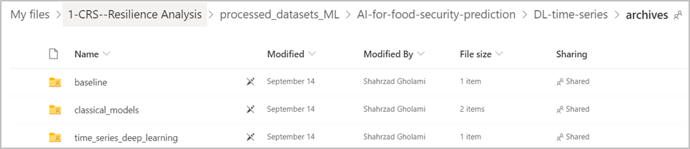

Working at Azure Portal with the Storage account, use the **BLOB CONTAINERS** to store the datasets from this folder, at this point use Microsoft Azure Storage Explorer to upload the Folders from local drive to Azure containers

1. For input/output data storage, please download and Install Microsoft Azure Storage Explorer

<https://azure.microsoft.com/en-us/features/storage-explorer/>

1. Before installing this tool, you need to install the .NET Framework 4.8

<https://dotnet.microsoft.com/download/dotnet-framework>

1. Connect Azure Storage via this Explorer by “**Add an account**”, the system asks you to **Sign in** to your account, then **Apply** to achieve this connection

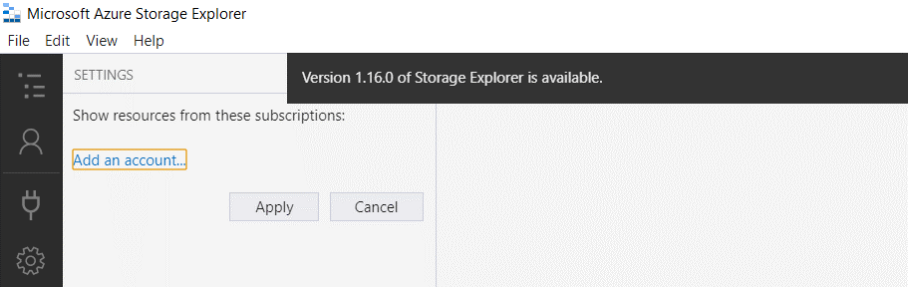

1. Create folders by respecting this structure, with your subscription, expand **Storage Accounts** go to **Blob Containers** and click on your **azureml-blobstore**-id and then add folders as **mira > malawi**
2. Upload the dataset from the folder **archives** by clicking on Upload icon  and select **Upload Folder**…

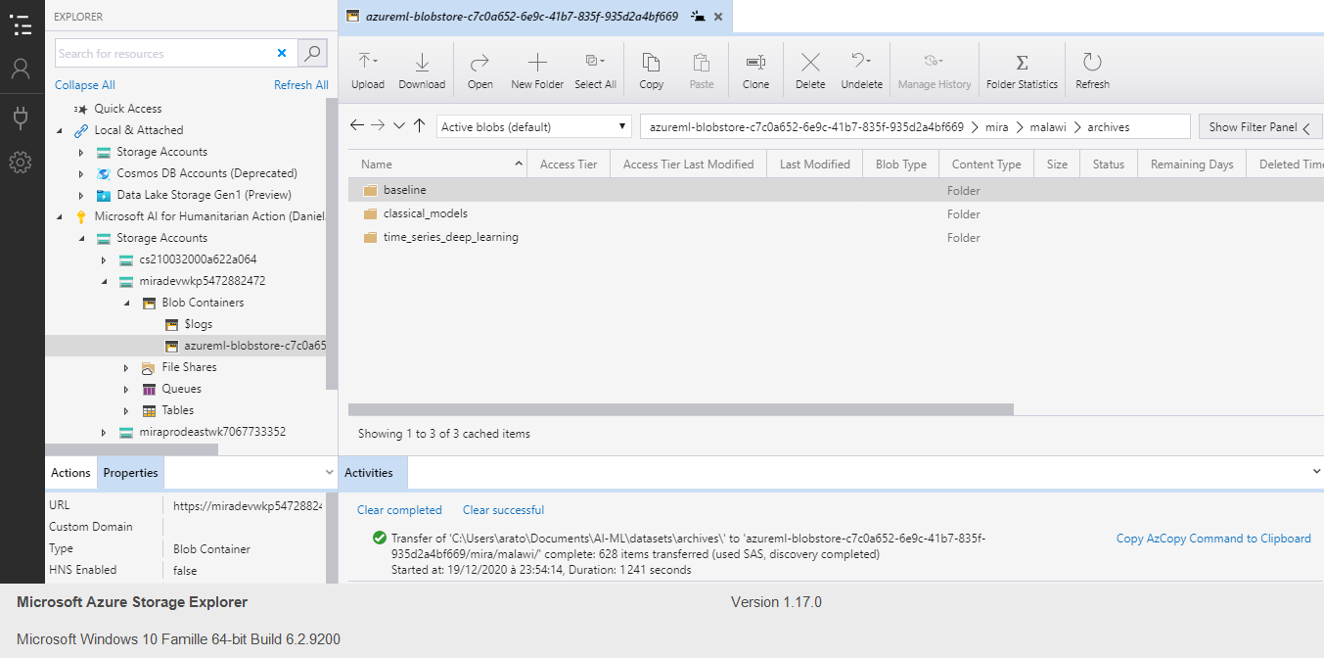

1. Verify if the Datasets are storage in your blob container, in your Azure Portal open the Storage account by clicking on storage_account_name, go to St**orage Explorer** (preview)

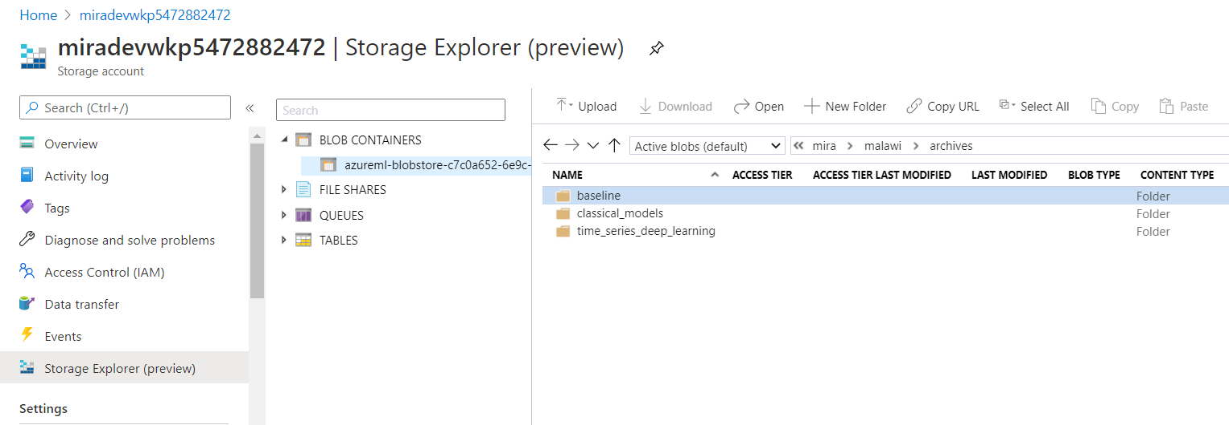

## **How to run ML model**

After uploading the Dataset to blob storage, we have to upload the ML models developed and provided by Microsoft Team. The codes are shared at Git repository **Repos** into **Azure DevOps** via this link

 [Repos](https://dsnaexternal@dev.azure.com/dsnaexternal/Catholic%20Relief%20Services/_git/Catholic%20Relief%20Services), before running and testing machine learning models on Azure computes via your Azure subscription, we must assure the different setups and follow the following steps

**Procedure Outline**

1. Log into your Azure subscription via [Azure Portal]
2. From Azure service choose Machine Learning
3. Set up the Workspace in Azure Machine Learning (*refer the section on how to create ML Workspace)*
4. Set up the Azure GPU Compute (*refer the section on how to create Azure ML Compute Cluster)*
5. Upload data for each country under a separate directory in your azure blob storage using explorer (*refer the section on How to Upload data to Azure container*)
6. Install and set up the Visual Studio Code (*refer the below section*)
7. Cloning Repository
   * Use Git Clone to get the codes
   * Try to understand the contents for the inputs in ML Pipeline
8. Build a custom docker image on Azure: Install docker extension in VS Code, then build image in Azure
9. Running and submitting the Experiments to the cloud using Visual Studio Code (VS Code)
   * Update the configuration file “DSNAGPUCOMPUTE-PrivateImage-UserManaged-rc2.runconfig”
   * Use create experiment extension in VS Code to create an experiment in your workspace.
10. Install Visual Studio if nor done already
    1. Download and Install Visual Studio Code editor for Windows [https://code.visualstudio.com/](https://nam03.safelinks.protection.outlook.com/?url=https%3A%2F%2Fcode.visualstudio.com%2F&data=04%7C01%7CAnusha.Eregowda%40crs.org%7C227e49708f544ac044bf08d8718cf58a%7Cb80c308cd08d4b07915c11a92d9cc6bd%7C0%7C0%7C637384197533664872%7CUnknown%7CTWFpbGZsb3d8eyJWIjoiMC4wLjAwMDAiLCJQIjoiV2luMzIiLCJBTiI6Ik1haWwiLCJXVCI6Mn0%3D%7C1000&sdata=A7I4ChiC6TrgxD7TQAMGJ0PJWGEx9OsCVBzOZb01Byg%3D&reserved=0)
    2. VSCode is a free code editor which runs on Windows operating system, with this editor you can see, edit, save and run your codes.
    3. Use VSCode to add the correct extensions for the programming language that you want to use (Python, Java, PHP, …). For this project this is the list of Extensions that you must install and sign into your Azure Subscription (Sign into your Azure account from Visual Studio Code)

|  |  |
| --- | --- |
| Extension | Description |
| Azure Account | The Azure Account extension provides a single Azure sign-in and subscription filtering experience for all other Azure extensions. It makes Azure's Cloud Shell service available in VS Code's integrated terminal. *Sign into your Azure account from Visual Studio Code* |
| Azure Machine Learning | With the Azure Machine Learning for Visual Studio Code extension you can easily build, train, and deploy machine learning models to the cloud or the edge with Azure Machine Learning service from the Visual Studio Code interface. Earlier versions of this extension were released under the name Visual Studio Code Tools for AI. *Use the Azure Machine Learning extension to run a sample script* |
| Python | A Visual Studio Code extension with rich support for the Python language (for all actively supported versions of the language: >=3.6), including features such as IntelliSense, linting, debugging, code navigation, code formatting, Jupyter notebook support, refactoring, variable explorer, test explorer, snippets, and more! |
| Docker | The Docker extension makes it easy to build, manage, and deploy containerized applications from Visual Studio Code. It also provides one-click debugging of Node.js, Python, and .NET Core inside a container.  *The Docker extension contributes a Docker Explorer view to VS Code. The Docker Explorer lets you examine and manage Docker assets: containers, images, volumes, networks, and container registries. If the Azure Account extension is installed, you can browse your Azure Container Registries as well.* |

* 1. Install the Extension “Azure Account”

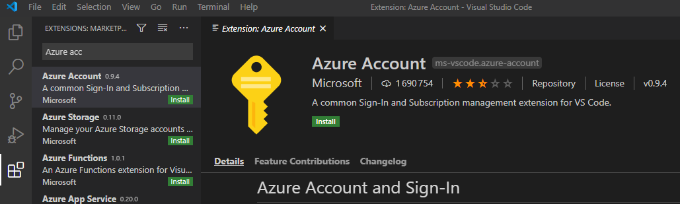

* Open Visual Studio Code.
* Select Extensions icon 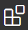 from the Activity Bar to open the Extensions view.
* In the Extensions view, search for "Azure Account".
* Select Install

<https://docs.microsoft.com/en-us/azure/machine-learning/tutorial-setup-vscode-extension>

* 1. Sign into your Azure Account

In order to provision resources and run workloads on Azure, you have to sign in with your Azure account credentials (with browser, use your username and password to connect your Azure portal)

* + 1. Open the command palette by selecting View > Command Palette from the menu bar.
    2. Enter the command "**Azure: Sign In**" into the command palette to start the sign in process.
    3. After signing on Azure Portal, the VSCode is connected to your azure subscription, you should be able to see your workspace

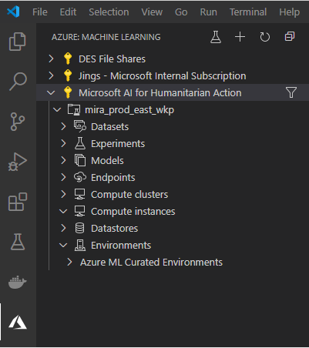

1. Clone the Repository

Via VS Code, you can clone a Git repository with the **Git: Clone** command in the Command Palette (Ctrl+Shift+P). You will be asked for the URL of the remote repository (for example on GitHub) and the parent directory under which to put the local repository. For a GitHub repository, you would find the URL from the GitHub Clone or use direct download

* 1. Download to local drive the Codes from the GitHub [Repos](https://dsnaexternal@dev.azure.com/dsnaexternal/Catholic%20Relief%20Services/_git/Catholic%20Relief%20Services)
  2. Open this link and use **Git: Clone** to access in your Visual studio Code
  3. With EXPLORER at Activity Bar, click on Open Folder to Upload the downloaded codes from your local drive

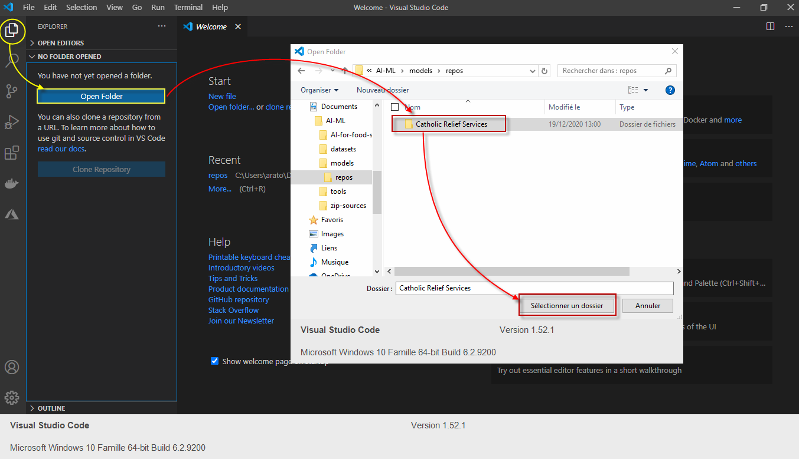

* 1. Read the **ReadMe.md** file to understand the codes on this ML pipeline

**Machine Learning Model Codes**

The code is divided as follows:

* The [main.py](https://dev.azure.com/dsnaexternal/_git/Catholic%20Relief%20Services?path=%2Fmain.py&version=GBmaster)python file contains the necessary code to **run an experiment**.
* The [utils](https://dev.azure.com/dsnaexternal/_git/Catholic%20Relief%20Services?path=%2Futils&version=GBmaster) folder contains the necessary functions to read the datasets and visualize the plots. [utils/constants.py](https://dev.azure.com/dsnaexternal/_git/Catholic%20Relief%20Services?path=%2Futils%2Fconstants.py&version=GBmaster) indicates the inputs to ML pipeline for each specific experiment, it should be modified accordingly and saved.
* The [classifiers](https://dev.azure.com/dsnaexternal/_git/Catholic%20Relief%20Services?path=%2Fclassifiers&version=GBmaster) folder contains python files one for each deep neural network or classical machine learning model.

1. Build a custom docker image on Azure

The [[custom_docker_image](https://dev.azure.com/dsnaexternal/_git/Catholic%20Relief%20Services?path=%2Fcustom_docker_image&version=GBmaster)] folder contains dock files to create an image on Azure with all prerequisites installed (Docker Extension should be installed at VS Code). This image should be built only one time on the Azure container registry.

The name of this image is used in [aml_config/DSNAGPUCOMPUTE-PrivateImage-UserManaged-rc2.runconfig]

* 1. In Azure Portal, If the Container Registry is not yet created during setting the ML Workspace, so add+ the new service as Container Registry

Steps: Azure Portal [**Home**] à open machine-learning-name [exp: **miradev_ml**] à add[**Container Registry**] à define(subscription, workspace, location[**East US**], registry name)

* 1. In VS Code, Docker extension should be installed, and then Build Image in Azure

Steps: Folder [ **custom_docker_image]** à Right click [**Dockerfile**] à [**Build Image In Azure…]** àat command, select container_registry_name [exp: **miradevregistry**]àselect[**Linux**]

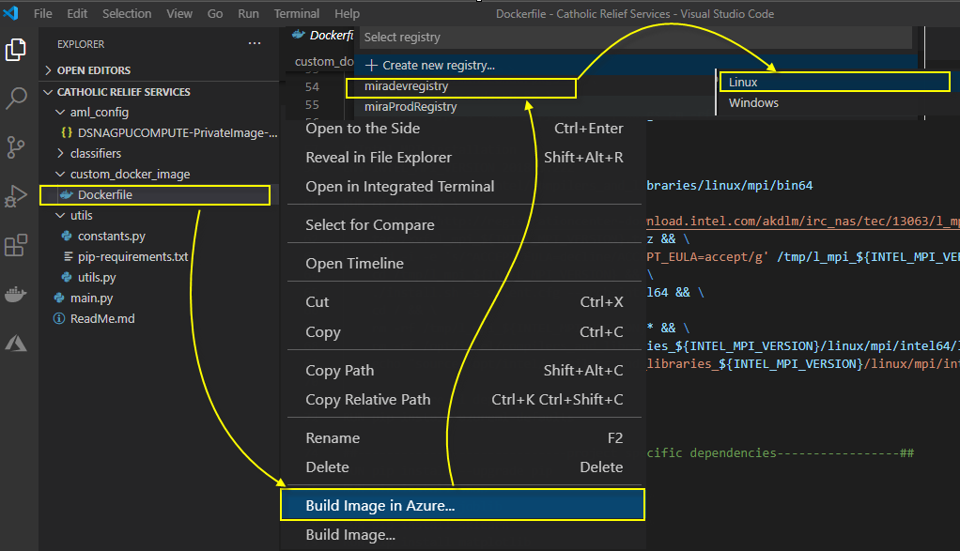

* 1. Back to Azure portal, refresh and check if the Tag as **ca1** of the repository is there

Steps: Azure Portal [**Home**] à container_registry_name [**miradevregistry**] à [**Repositories**] à [**custom_docker_image**] à Tag: [**ca1**]

* Repository: custom_docker_image
* Tag: ca1
* Docker pull command(baseImage): **miradevregistry.azurecr.io/custom_docker_image:ca1**

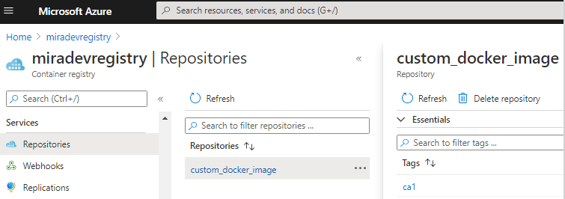

1. Run the Experiments

You will need to link your Azure subscription to your VS Code to run the experiments. To link your Azure account to VS code, the below resources would help:

[Azure Sign in](https://nam03.safelinks.protection.outlook.com/?url=https%3A%2F%2Fdocs.microsoft.com%2Fen-us%2Fazure%2Fmachine-learning%2Ftutorial-setup-vscode-extension&data=04%7C01%7CAnusha.Eregowda%40crs.org%7C227e49708f544ac044bf08d8718cf58a%7Cb80c308cd08d4b07915c11a92d9cc6bd%7C0%7C0%7C637384197533674828%7CUnknown%7CTWFpbGZsb3d8eyJWIjoiMC4wLjAwMDAiLCJQIjoiV2luMzIiLCJBTiI6Ik1haWwiLCJXVCI6Mn0%3D%7C1000&sdata=nU2ESVmouPLj9AdKecpRAeiyt5QBup7jPWvn5AQFow8%3D&reserved=0)

[How to add the Azure Cloud Shell to Visual Studio Code | Azure Tips and Tricks](https://nam03.safelinks.protection.outlook.com/?url=https%3A%2F%2Fwww.youtube.com%2Fwatch%3Fv%3DpB_xjSg7fcQ&data=04%7C01%7CAnusha.Eregowda%40crs.org%7C227e49708f544ac044bf08d8718cf58a%7Cb80c308cd08d4b07915c11a92d9cc6bd%7C0%7C0%7C637384197533674828%7CUnknown%7CTWFpbGZsb3d8eyJWIjoiMC4wLjAwMDAiLCJQIjoiV2luMzIiLCJBTiI6Ik1haWwiLCJXVCI6Mn0%3D%7C1000&sdata=PqcsWpELJI2NSfIjMXRCP4Ii%2BUoypIYy9CvYIOqxX14%3D&reserved=0)

To run a model on one dataset you should issue the following command:

python3 main.py time_series_deep_learning MIRA-ts cnn _itr_1 18 38 2

which means we are launching the **cnn.py** model on the time-series deep learning archive for the MIRA time series dataset in the first iteration where the time-series length is 18, the binary cutoff point for dataset labels is 38 and the case number is 2 (see constants.py for a list of possible options). These arguments allow the scripts to read and write proper datasets and run a customized experiment.

**Prerequisites**

All python packages needed are also listed in [pip-requirements.txt](https://dev.azure.com/dsnaexternal/_git/Catholic%20Relief%20Services?path=%2Futils%2Fpip-requirements.txt&version=GBmaste) file and can be installed simply using the pip command. The code uses Tensorflow 2.0.

* [numpy](http://www.numpy.org/)
* [pandas](https://pandas.pydata.org/)
* [sklearn](http://scikit-learn.org/stable/)
* [scipy](https://www.scipy.org/)
* [matplotlib](https://matplotlib.org/)
* [tensorflow-gpu](https://www.tensorflow.org/)
* [keras](https://keras.io/)
* [h5py](http://docs.h5py.org/en/latest/build.html)
* [keras_contrib](https://www.github.com/keras-team/keras-contrib.git)
* [shap](https://github.com/slundberg/shap)
* [joblib](https://joblib.readthedocs.io/)

When the ML Pipeline (codes) are uploaded to VS Code platform, we start to modify and save the config file, create a new experiment and then run and submit this experiment to Azure Machine Learning.

* 1. Modify the config file [/aml_config/DSNAGPUCOMPUTE-PrivateImage-UserManaged-rc2.runconfig]

In VS Code start to

Change the **dataRefernces** (DataStore,..)

Source

    "script": "main.py",

    "arguments": [

        "--input-dir",

        "$AZUREML_DATAREFERENCE_jupyterhubfilestore",

        "--output-dir",

        "outputs"

    ],

"sourceDirectoryDataStore": null,

    "framework": "Python",

    "communicator": "None",

    "target": "DSNAGPUCOMPUTE",

    "dataReferences": {

        "jupyterhubfilestore": {

            "dataStoreName": "jupyterhubfilestore",

            "mode": "Mount",

            "pathOnDataStore": "shahrzadgholami/AI-for-food-security-prediction/DL-time-series",

            "pathOnCompute": null,

            "overwrite": true

        }

Change and save the

1. dataStoreName: “jupyterhubfilestore” to "**workspaceblobstore**",
2. pathOnDataStore: “shahrzadgholami/AI-for-food-security-prediction/DL-time-series” to “**mira/malawi**”
3. target: "DSNAGPUCOMPUTE” to “**miradev-cluster**”
4. arguments: "$AZUREML_DATAREFERENCE_jupyterhubfilestore", to "**$AZUREML_DATAREFERENCE_ workspaceblobstore**",

  "script": "main.py",

"arguments": [

"--input-dir",

"$AZUREML_DATAREFERENCE_ workspaceblobstore",

"--output-dir",

"outputs"

],

"sourceDirectoryDataStore": null,

    "framework": "Python",

    "communicator": "None",

    "target": " miradev-cluster",

    "dataReferences": {

        "workspaceblobstore": {

            "dataStoreName": "workspaceblobstore",

            "mode": "Mount",

            "pathOnDataStore": "mira/malawi",

            "pathOnCompute": null,

            "overwrite": true

        }

Steps:

1. dataStoreName: **Azure Portal** à machine_learning_name [**miradev_wkp]**à [**Launch Studio]** à[**DataStore**s] è **workspaceblobstore**(default)

* Datastore type: Azure Blob Storage
* DataStore Name: **workspaceblobstore**
* Account name: **miradevwkp5472882472**
* Blob container: azureml-blobstore-c7c0a652-6e9c-41b7-835f-935d2a4bf669

1. pathOnDataStore: **Azure Portal** à storage_accunt_name [**miradevwkp5472882472**]à [**Storage Explorer (**preview**)**] à**BLOB CONTAINERS** à azureml-blobstore-c7c0a652-6e9c-41b7-835f-935d2a4bf669

* azureml-blobstore-c7c0a652-6e9c-41b7-835f-935d2a4bf669/**mira/malawi**

1. target: **Azure Portal** à machine_learning_id [**miradev_wkp]**à [**Launch Studio]** à[**Compute]** è **Compute clusters**

* Compute name: **miradev-cluster**

**Change Dockerfile**

Source

        "docker": {

            "baseImage": "dsnaamlcontainerregistry.azurecr.io/crs_ai_for_food_security_image:latest",

            "baseDockerfile": null,

            "enabled": true,

            "sharedVolumes": true,

            "gpuSupport": true,

            "shmSize": "2g",

            "arguments": [],

            "baseImageRegistry": {

                "address": "dsnaamlcontainerregistry.azurecr.io",

                "username": null,

                "password": null

            }

Change and save the

1. baseImage: "dsnaamlcontainerregistry.azurecr.io/crs_ai_for_food_security_image:latest", to "**miradevregistry.azurecr.io/custom_docker_image:ca1**",
2. address: “dsnaamlcontainerregistry.azurecr.io” to “**miradevregistry.azurecr.io**”

        "docker": {

            "baseImage": " miradevregistry.azurecr.io/custom_docker_image:ca1",

            "baseDockerfile": null,

            "enabled": true,

            "sharedVolumes": true,

            "gpuSupport": true,

            "shmSize": "2g",

            "arguments": [],

            "baseImageRegistry": {

                "address": " miradevregistry.azurecr.io",

                "username": null,

                "password": null

            }

Steps: dataStoreName: Azure Portal **[Home]** à container_registry_name [**miradevregistry]**à [**Repositories]** à[**custom_docker_image**] è Tag: [**ca1**]

* Repository: custom_docker_image
* Tag: **ca1**
* baseImage (docker pull command): **miradevregistry.azurecr.io/custom_docker_image:ca1**
* address(loginServer): **miradevregistry.azurecr.io**
  1. **Create and run an experiment**

**Go to Microsoft Azure option** 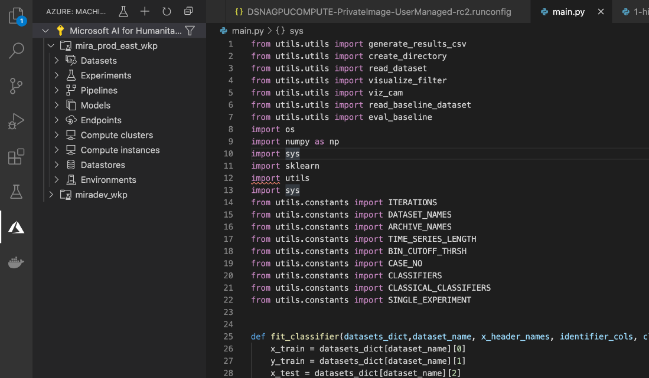

**Right click on Experiments --> Create Experiment**

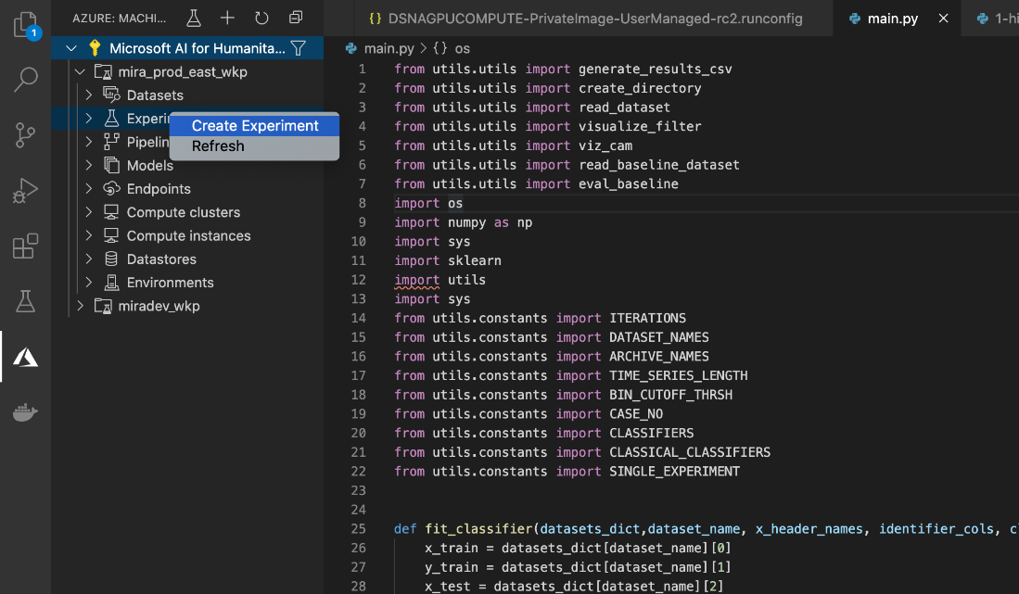

**Enter an experiment name**

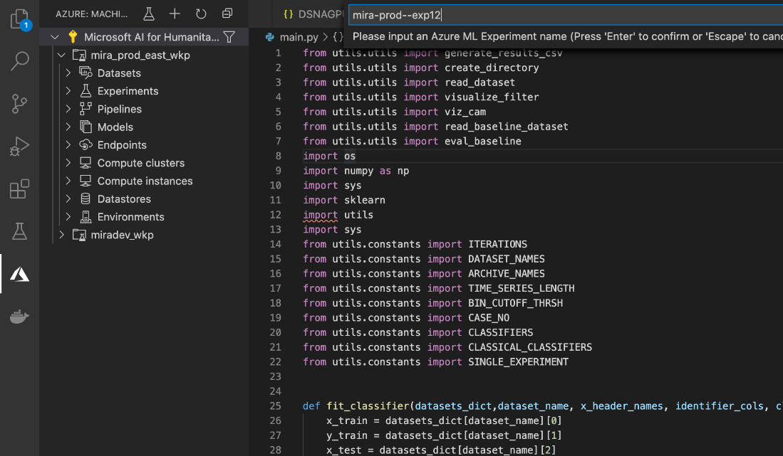

**Experiment is created.**

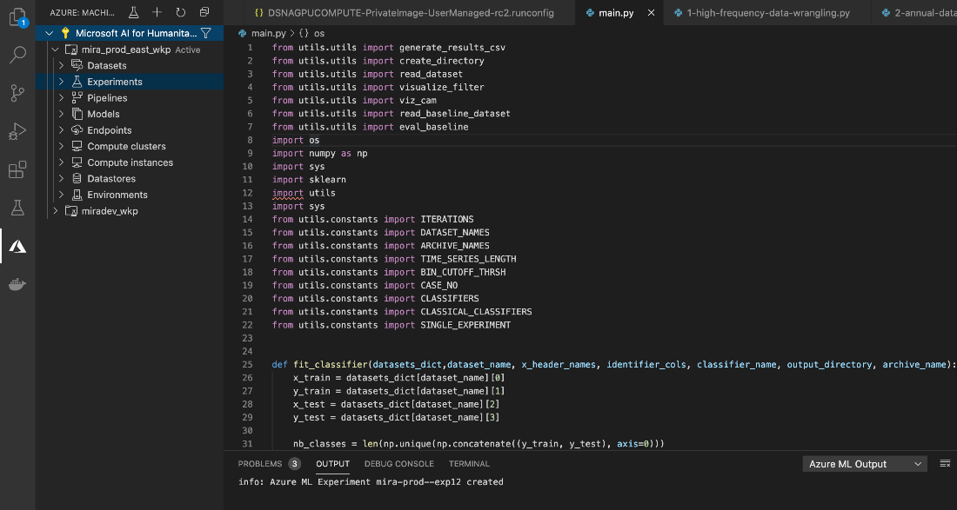

**Go to the Project (Catholic_Relief_Services) -> Right Click on Main.py -> Choose ‘Azure ML: Run as**  **Experiment in Azure’**

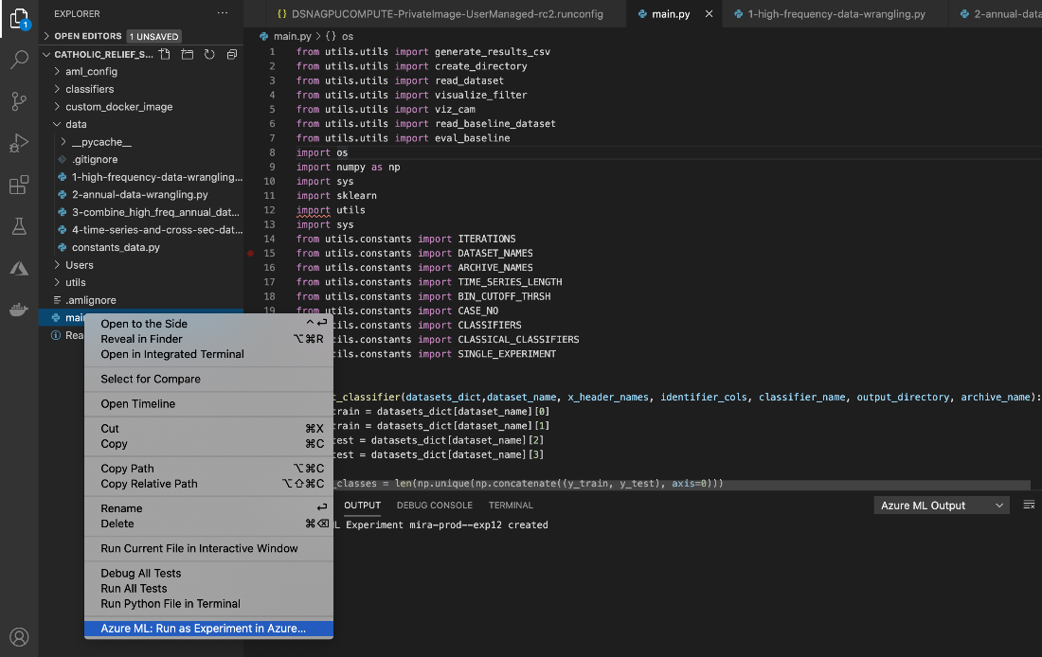

**Choose the Azure subscription as ‘Microsoft AI for Humanitarian Action’ from the command Palette and**  **press ‘Enter’**

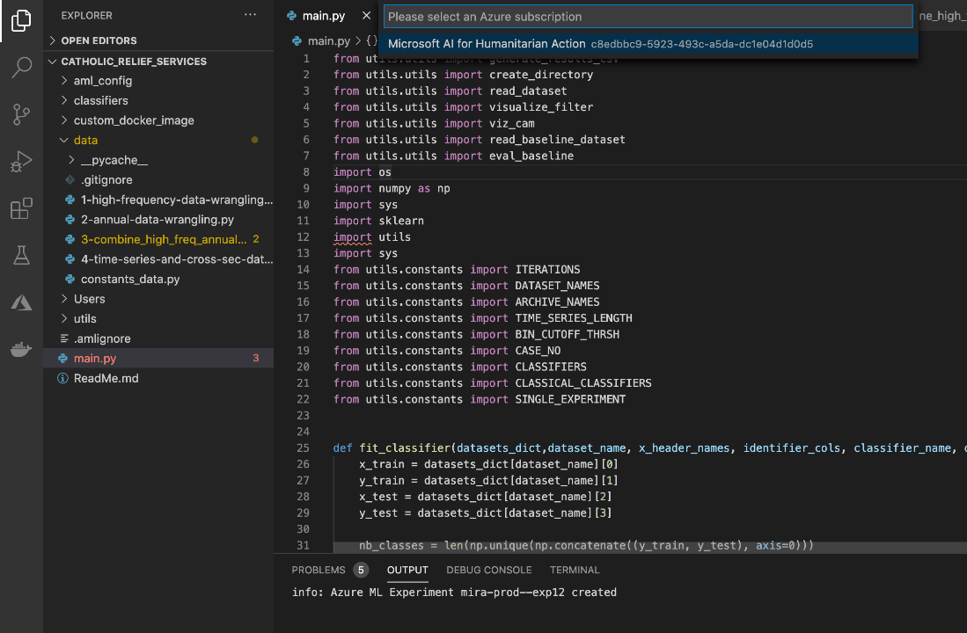

**Choose the Azure workspace as ‘mira_prod_east_wkp’ (or the workspace you have created) from the**  **command Palette and press ‘Enter’**

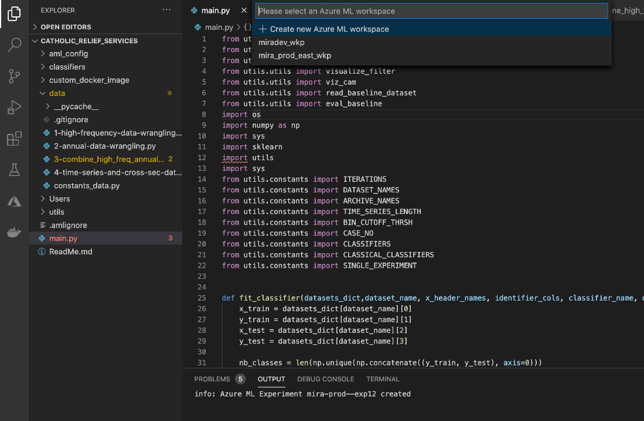

**Choose the compute as mira-prod-clustr from the command Palette and press ‘Enter’**

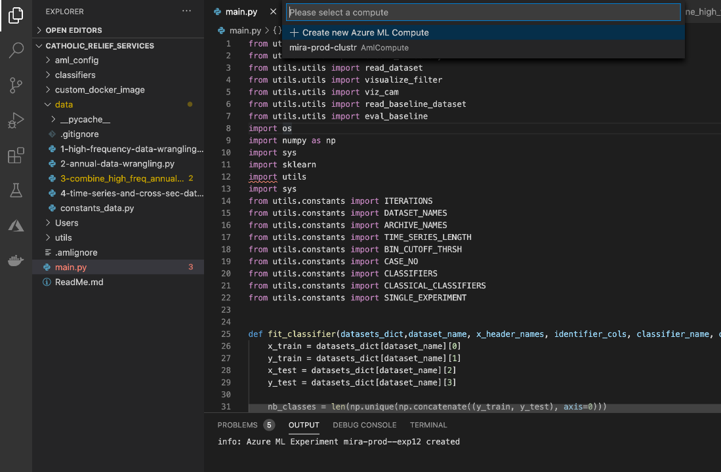

**Choose the Run configuration from the command Palette and press ‘Enter’**

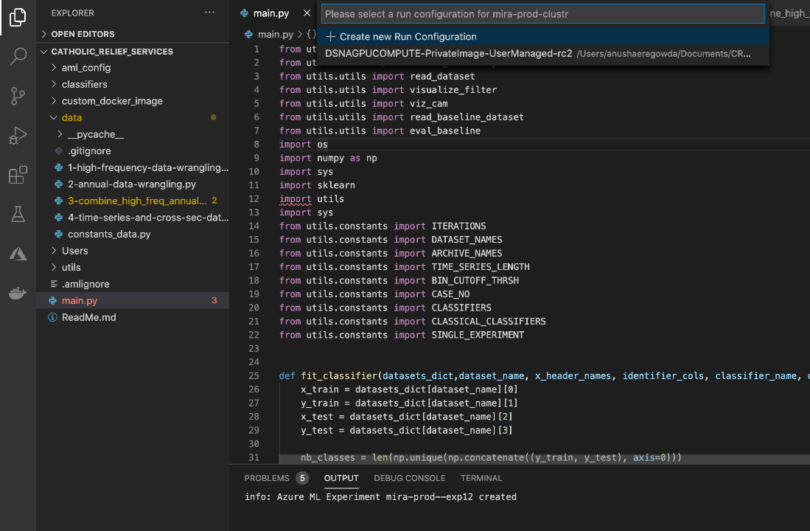

**You can see the experiments being submitted by a dialog box at the down rightmost corner.**

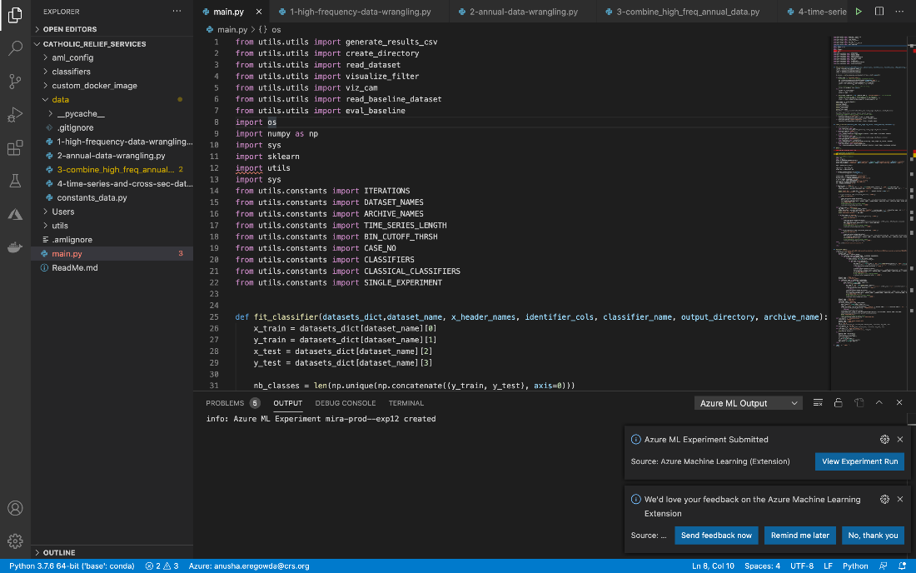

**Click on ‘Open’ to open in the portal**

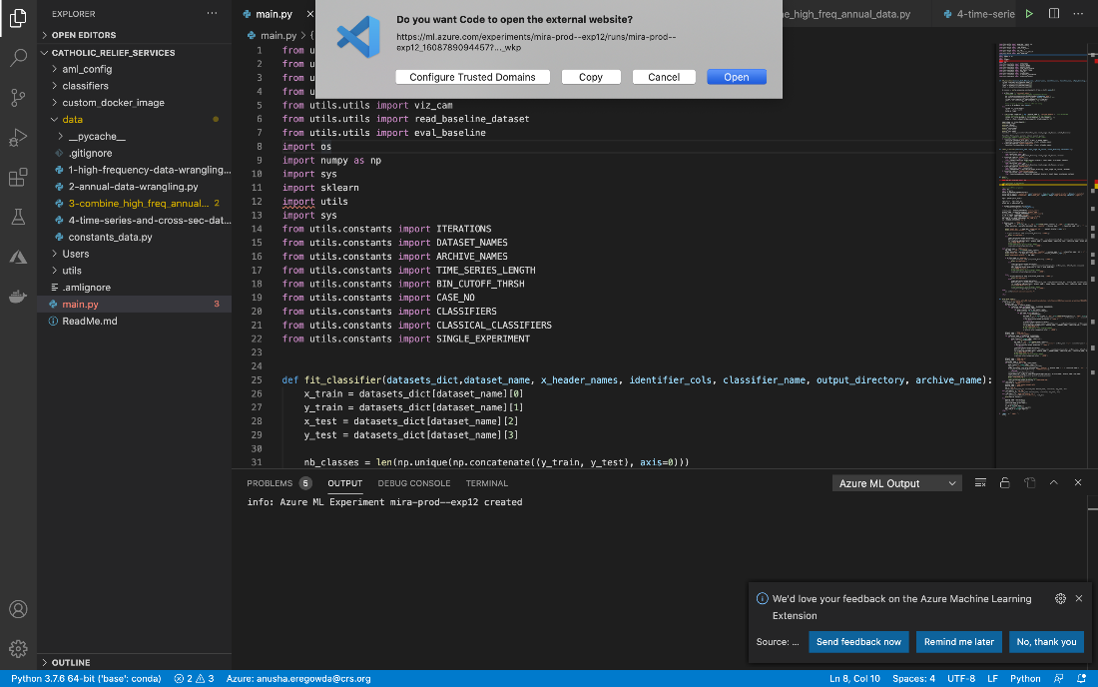

**Screenshot of the experiment running**

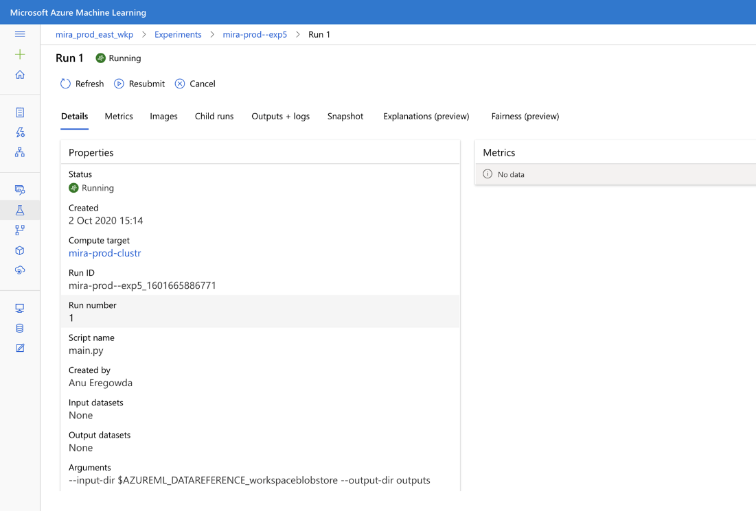

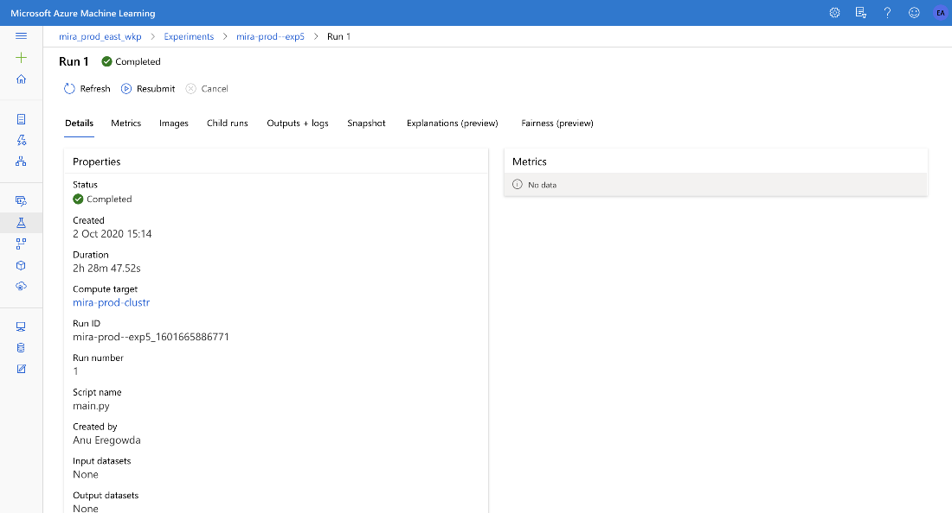

## **How to develop reports/visualization**

**Interpret Machine Learning models**

**rCSI (reduced coping strategy index)** is the target variable. This score is calculated by various predictor variables from the module.

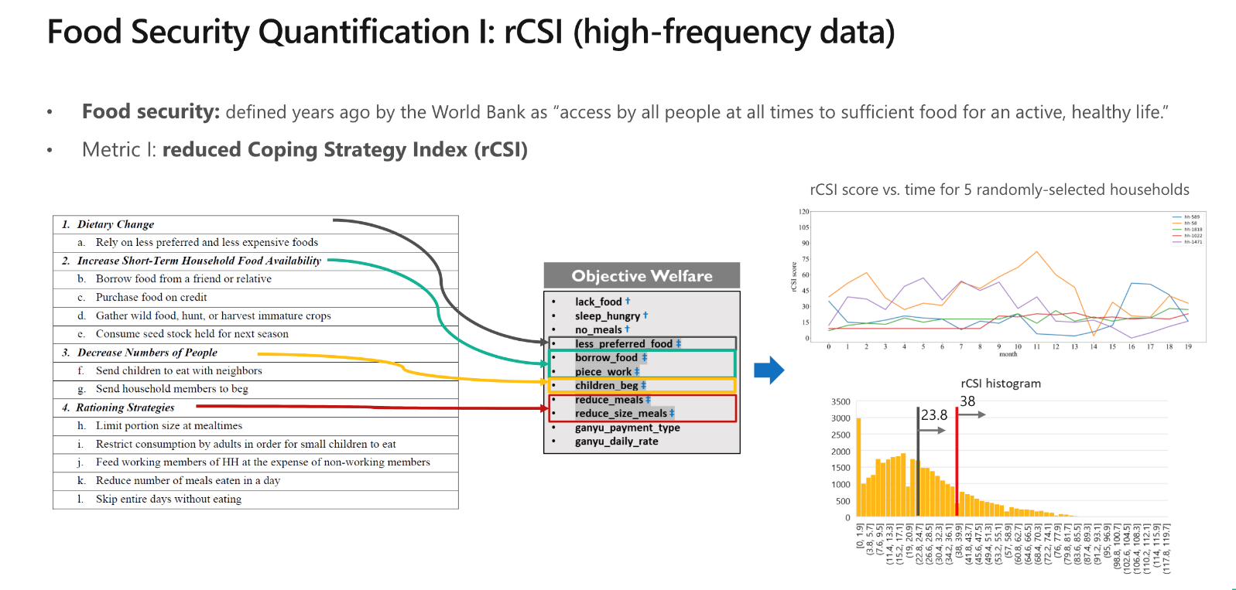

Factors involved in rCSI calculation

Two types of Machine Learning tasks have been performed on the Dataset to achieve the insights on community and household level respectively.

* **Machine Learning Task 1**: For the community level insights, classical regression modelling and SHAP analysis have been performed to find the variables that significantly affect the rCSI score.
* **Machine Learning Task 2:** For the household level insights, Binary classification time series modelling has been performed to predict the vulnerability of households.

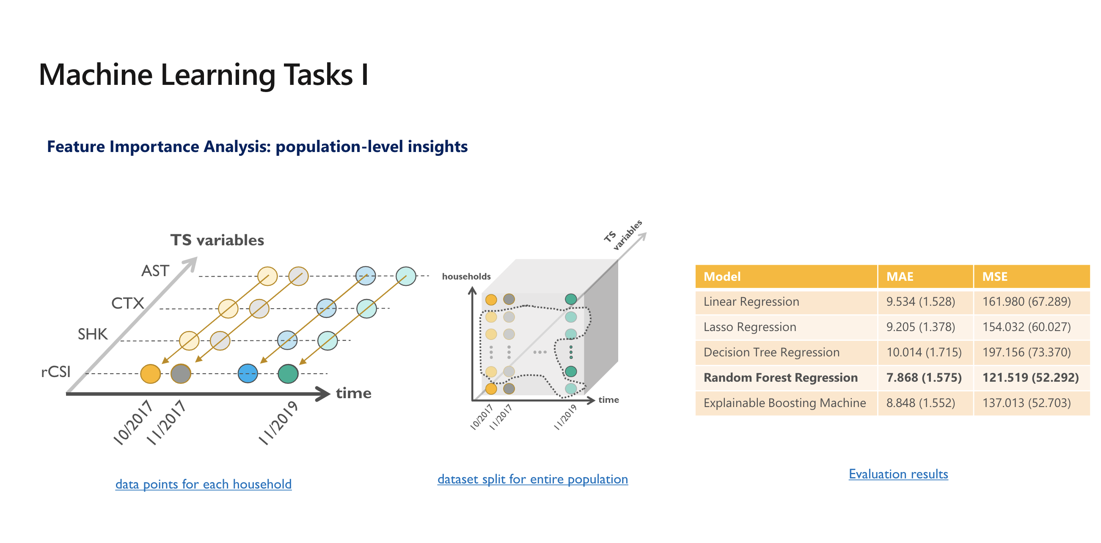

Diagram (iii)

Diagram (ii)

Diagram (i)



In the above figure,

* Diagram(i) – For the population or community level insights, the rCSI score for each month was calculated based on the values of the predictor variables of the same month.
* Diagram(ii) – Shows the randomly split dataset for entire population with time on the x-axis, households on the y-axis and time series variables on the other axis.
* Diagram(iii) – The evaluation results involving Mean Average Error (MAE) and Mean Square Error (MSE) of the various classical regression models are shown.

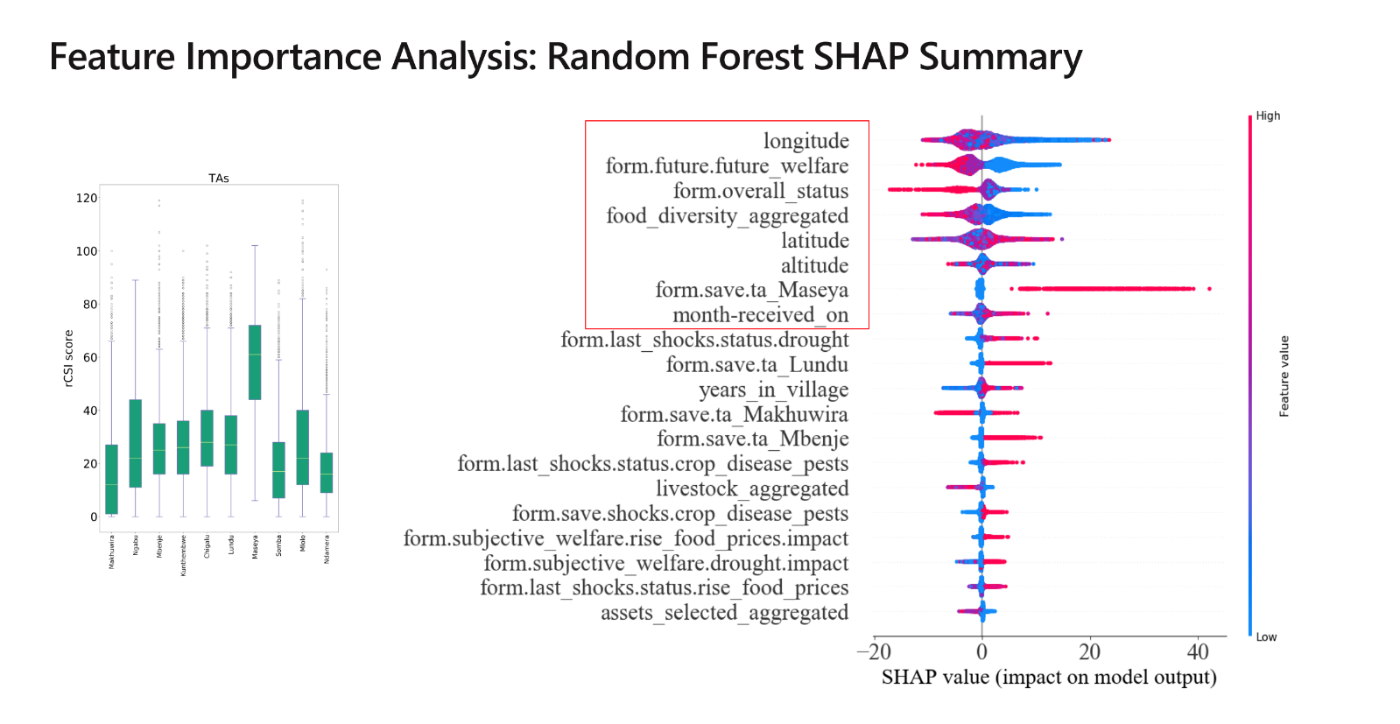

SHAP Analysis is performed to find the variables that significantly affect the rCSI score. The variables highlighted in red box are the top 10 important variables used to measure the food insecurity score.

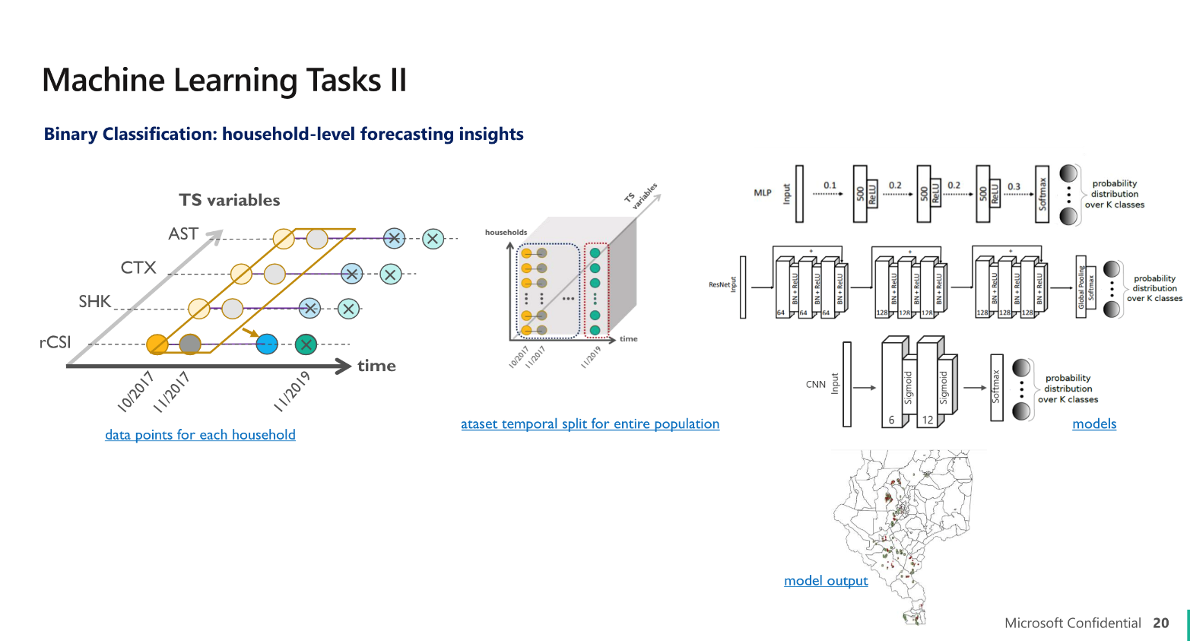

In Machine learning Task II, the future rCSI scores were calculated based on the historical data of the predictor variables using Time series deep learning model. Three deep learning models were used namely:

* Multilayer perceptron (MLP)
* Residual Neural Network (ResNet)
* Convolutional Neural Network (CNN)

The performance of the Binary classification model is measured by metrics like F1 score, Accuracy, Recall, Precision, AUC.

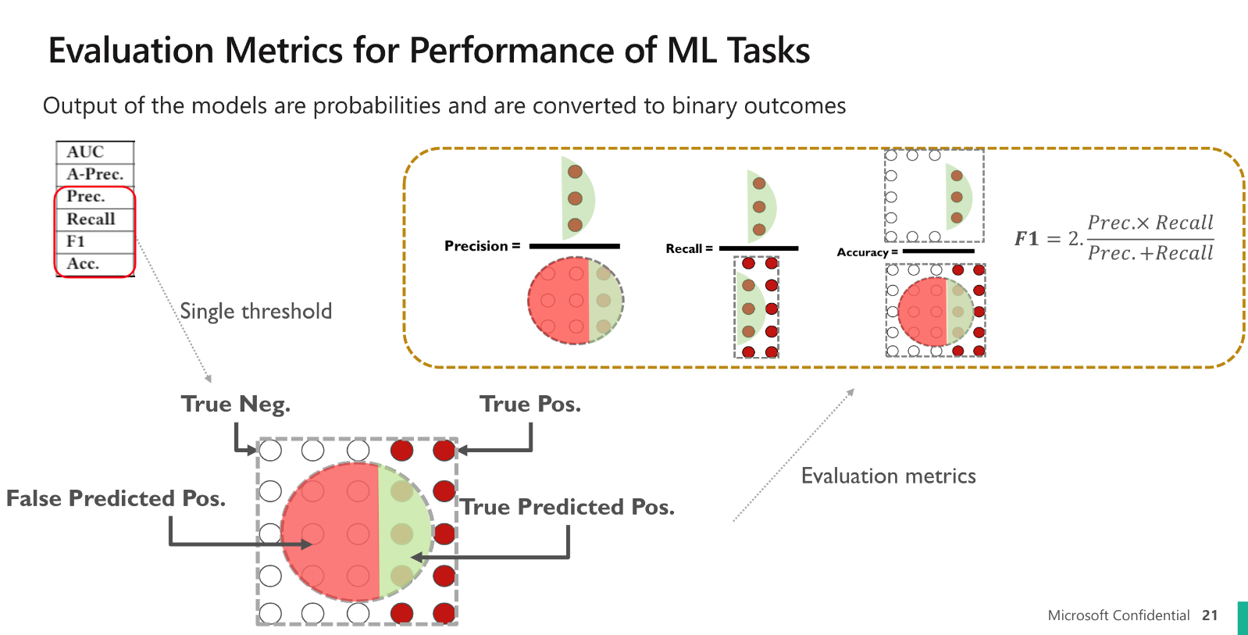

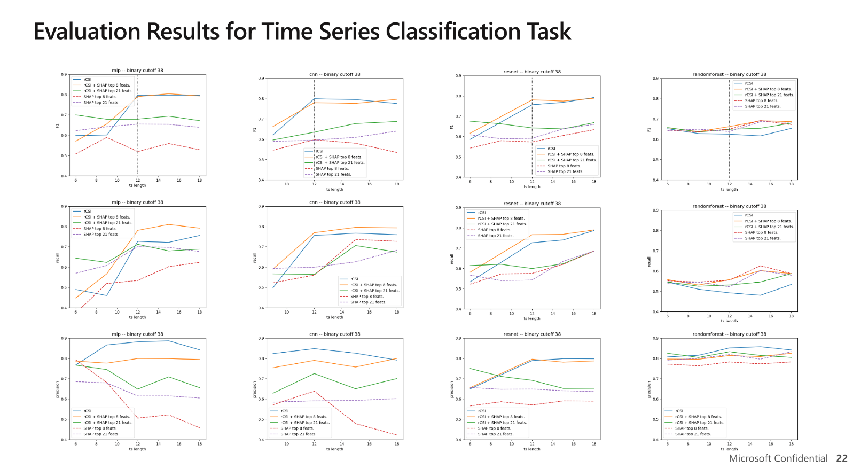

From the above figure:

1. The first row depicts the F1 score for each of the deep learning models plotted against the time length in months.
2. The second row depicts the recall for each of the deep learning models plotted against the time length in months.
3. The third row depicts the precision for each of the deep learning models plotted against the time length in months.

**Screenshots**

**Folder Structure of the results**

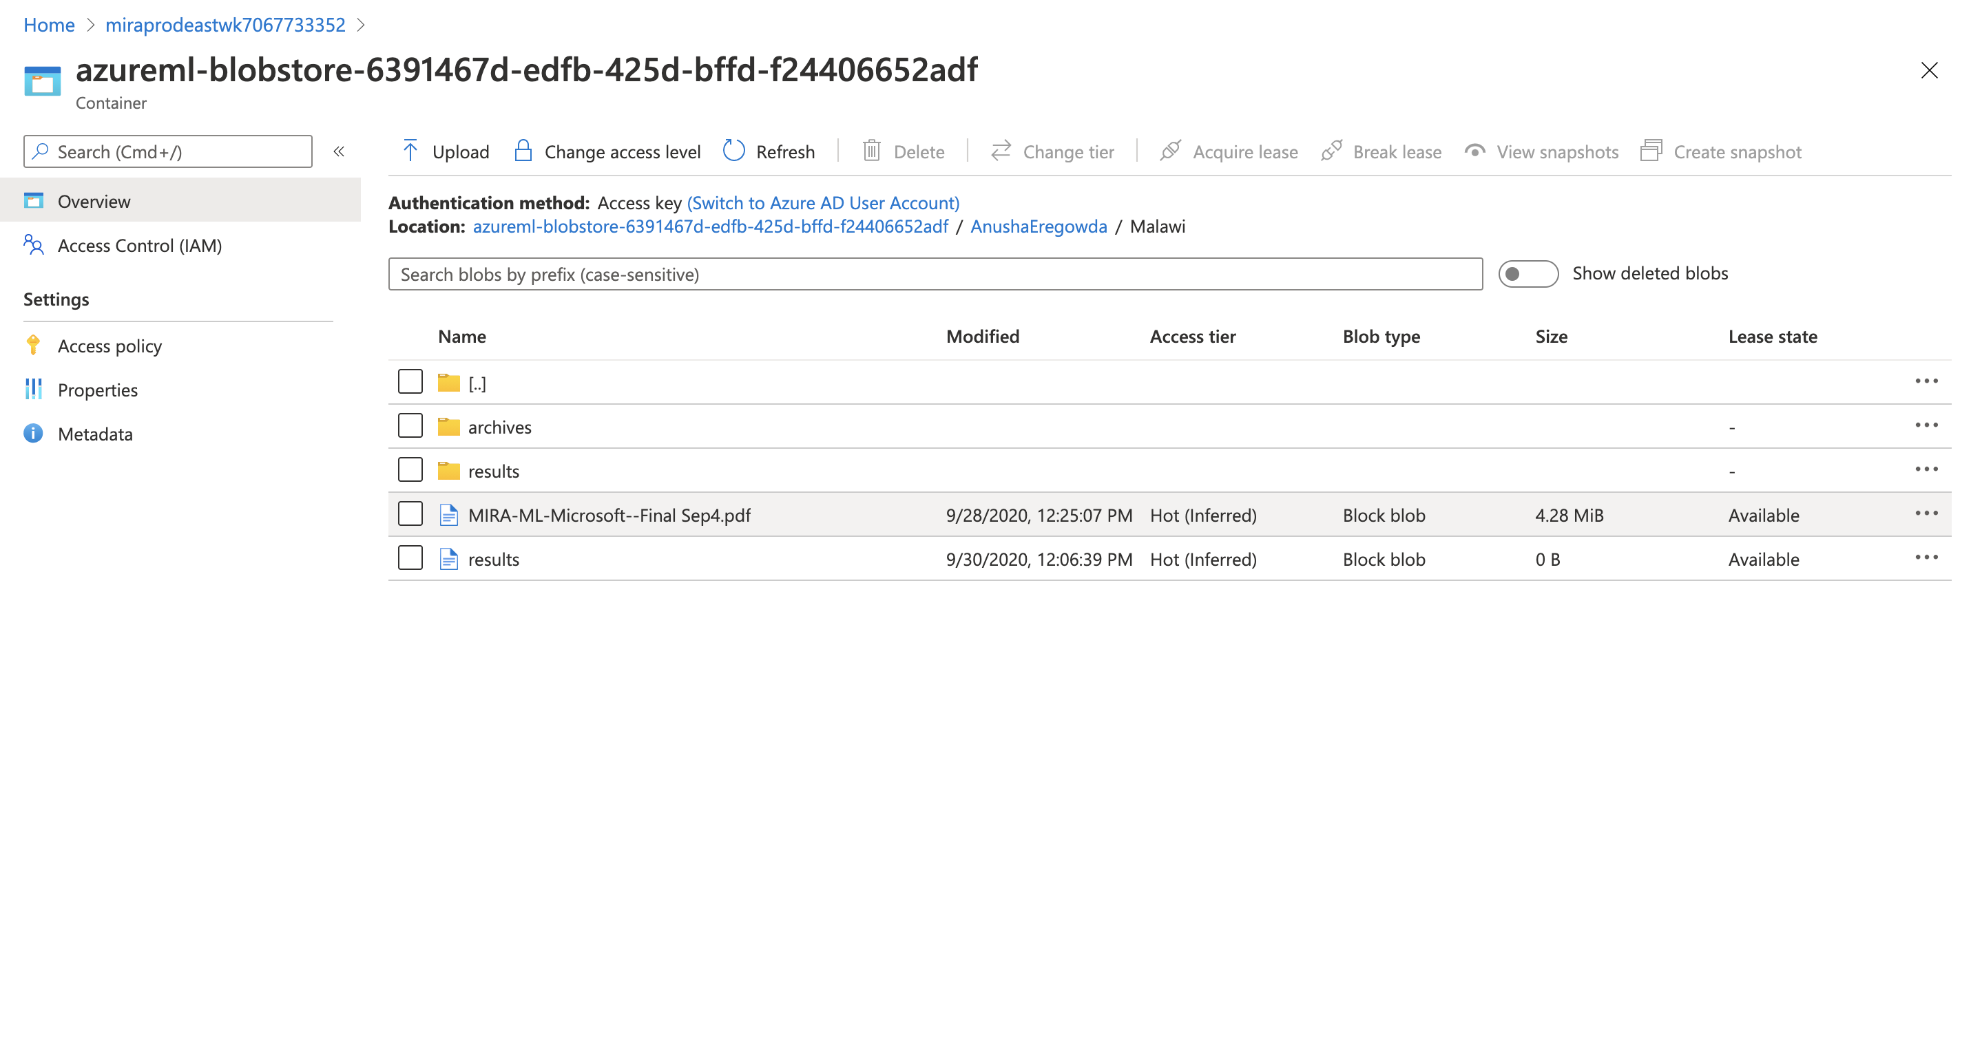

Folder structure of input data and output results

The above figure shows the folder structure of all the input and output files. The highlighted red box specifies the location on Azure.

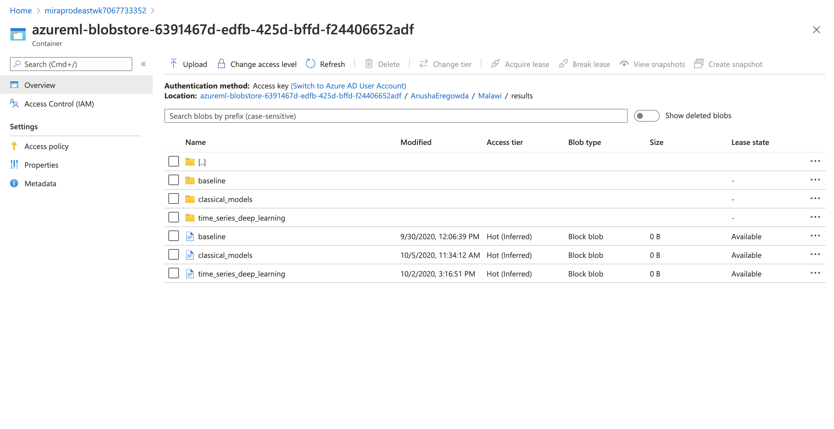

Structure of the output folders for different Machine Learning tasks

The above figure shows the folder structure of the results. The highlighted red box specifies the location on Azure.

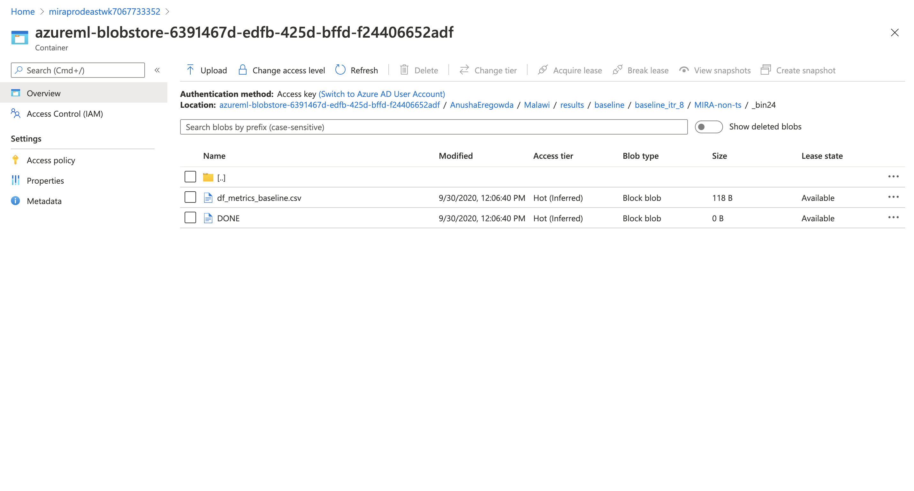

Simple Baseline model (no machine learning model was used)

The above figure shows the folder structure of the baseline model. The highlighted red box specifies the location on Azure.

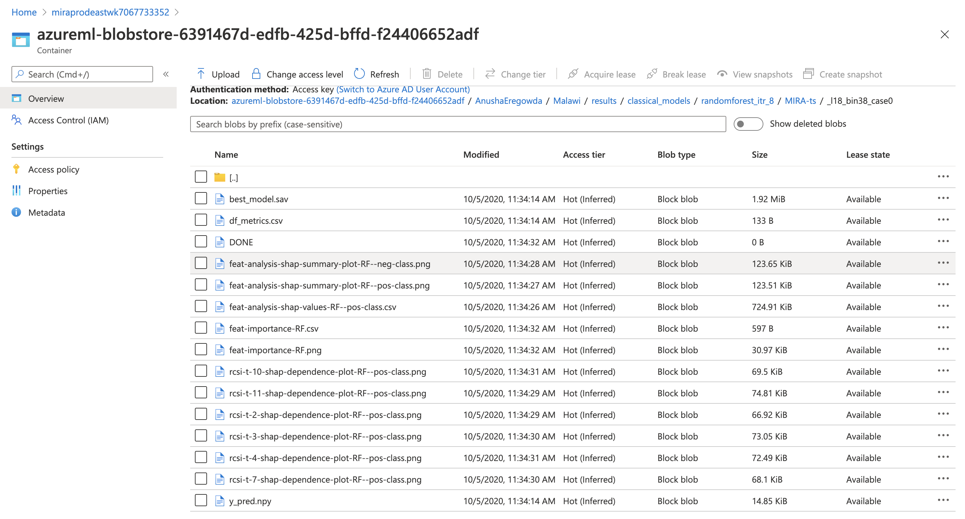

The above figure shows the folder structure of the classical model results. The highlighted red box specifies the location on Azure.

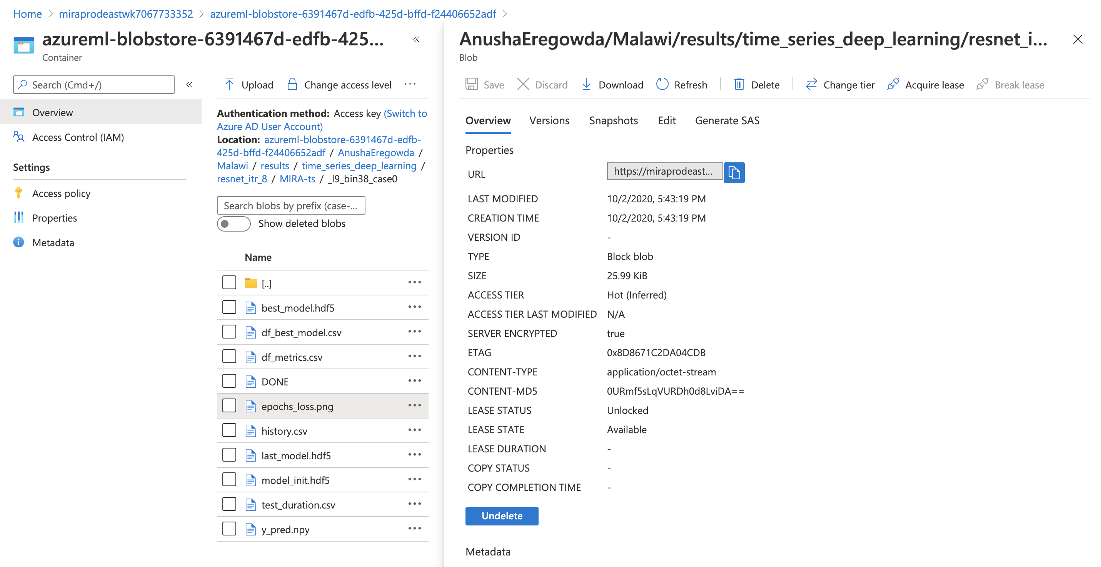

Figure 2 Inspect machine learning output in Azure Portal

The above figure shows the folder structure of the time series deep learning model. The highlighted red box specifies the location on Azure.



The files useful for the Domain expert are ‘df_metrics.csv’ and ‘y_pred.npy’ for taking business decisions. Rest are useful for the Data scientist.

* **‘df_metrics.csv’** contains the evaluation metrics.
* **‘y_pred.npy’** contains the actual output and probability predictions.

**‘DONE’** folder refers to the successful completion of the experiment.

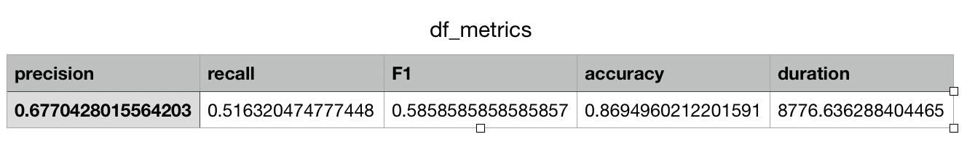

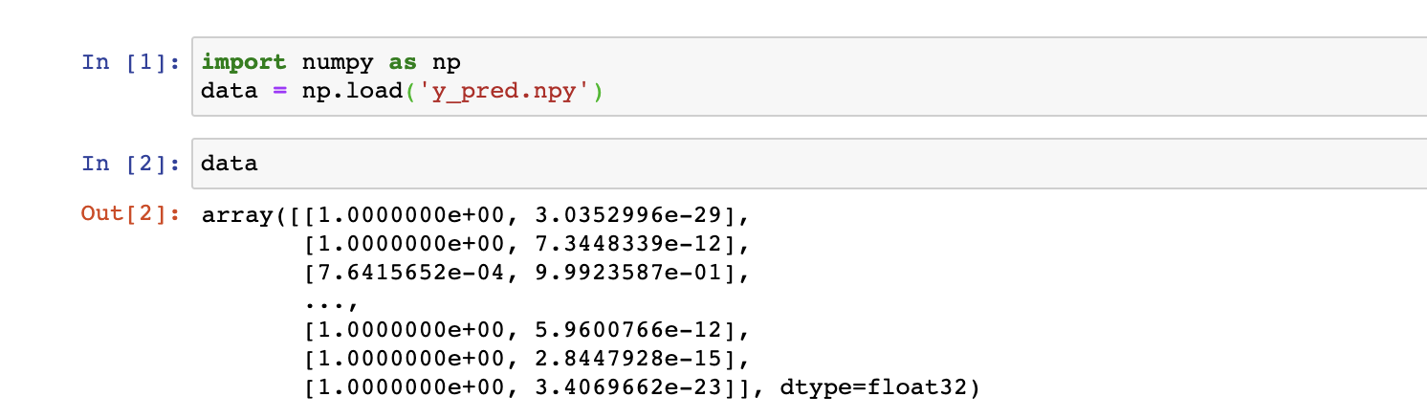

Reading the .npy file

**Creating the Model**

Before the creation model it is necessary to understand the business with the delimitation of the scope of work and lines of operation and the products that will be generated with the use of the code.

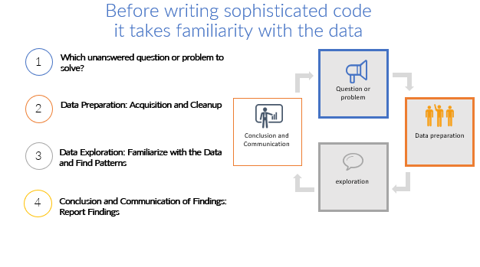

The application of this model is capable of generating several products to support scaling.

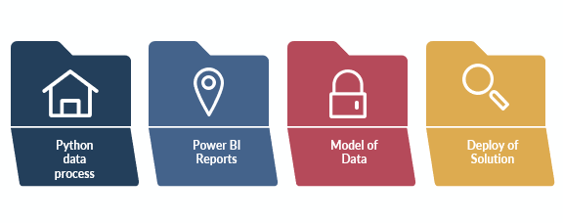

**Pycaret Clustering**

The first thing to do is to set up a setup in the azure environment. This virtual machine must have the following infrastructure requirements:

1. GPU with 32 gigs of RAM
2. High-running environment and memory consumption.
3. Split processing into more than one machine

Libraries:

* 1. Sklearn
  2. Pycaret
  3. Numpy
  4. Pandas
  5. Xgboost
  6. Matplotlib
  7. Seaborn
* 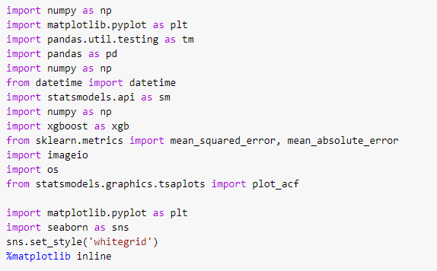

This function initializes the training environment and creates the transformation pipeline. Setup function must be called before executing any other function. It takes one mandatory parameter: data. All the other parameters are optional.

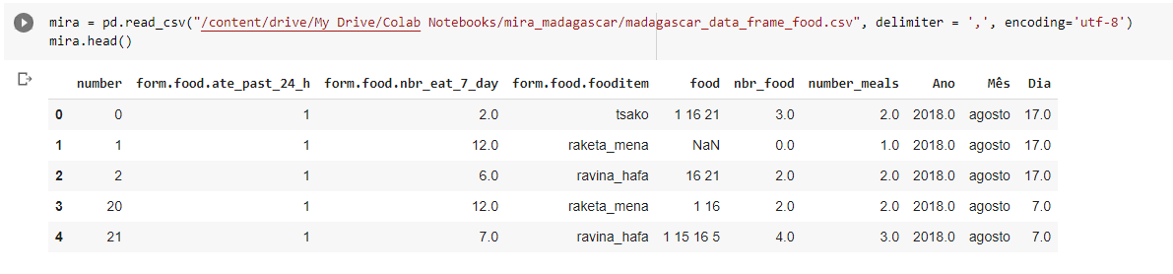

Exploration of the dataset:

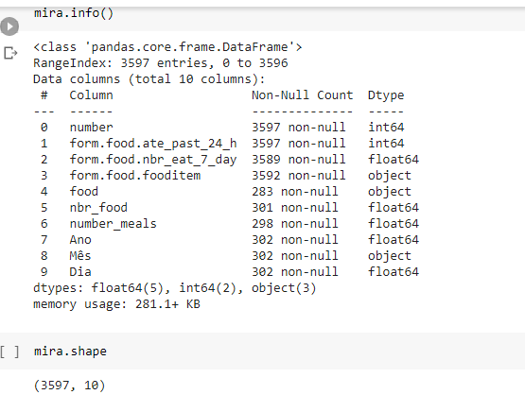

Exploratory analysis of strategic information. Example: Number of meals per year.

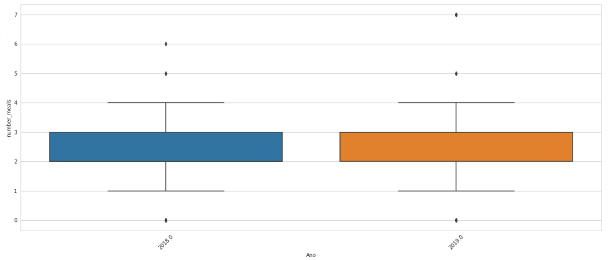

Exploratory analysis of strategic information. Example: Number of meals per day of the month, possible verification that communities in madagascar have greater access to meals at the beginning of the month.

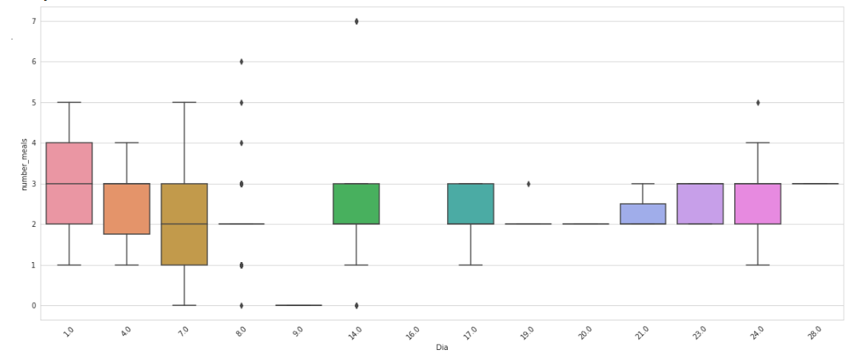

To create the cluster model we analyze the correlation of variables that will be used in the model.

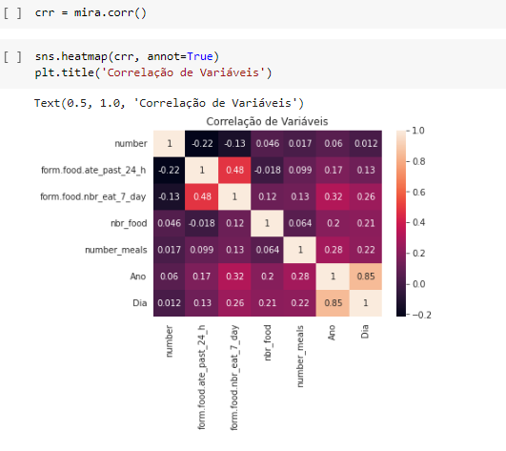

Import ing the data model into Pycaret.

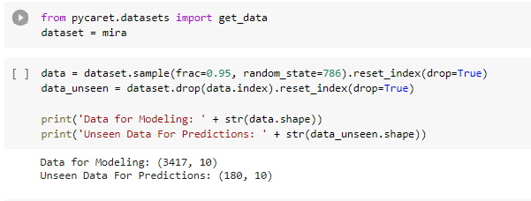

Pycaret analyzes the data types of each column that prompts you to confirm the information, at which point you can make the change of data type for training in the model.

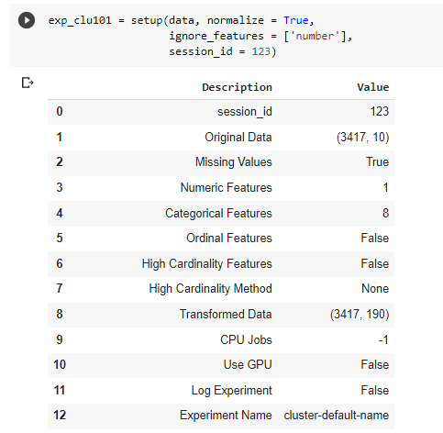

We apply the kmeans algorithms segregate around various data centers, creating what analogously in chemistry we call clustering that generates the effect of partitioning n observations among k groups where each observation belongs to the group closest to the average

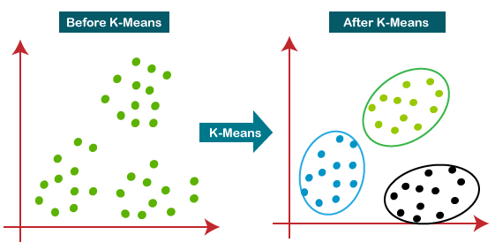

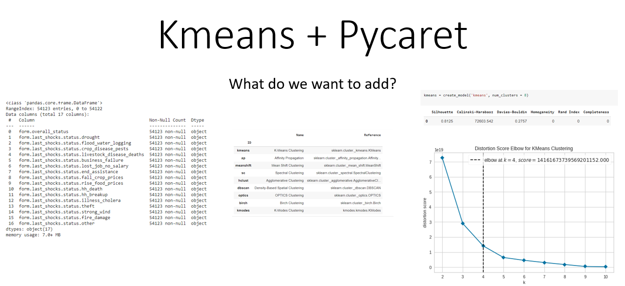

After confirmation of the information is the time of training of the model based on the data provided. It is important to note that pycaret will do all the data processing and balancing before training the model. After that we will have the results generated by the data model. This function creates a model on the dataset passed as a date param during the setup stage. setup() function must be called before using create_model(). This function returns a trained model object.

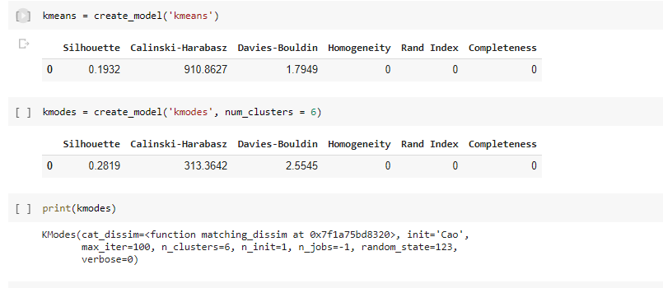

This function assigns each of the data point in the dataset passed during setup stage to one of the clusters using trained model object passed as model param. create_model() function must be called before using assign_model(). This function returns a pandas Dataframe. Os dados podemos ser visualizados em dataset e a distribuição dos clusters. This function is used to predict new data using a trained model. It requires a trained model object created using one of the function in pycaret that returns a trained model object. New data must be passed to data param as pandas Dataframe.

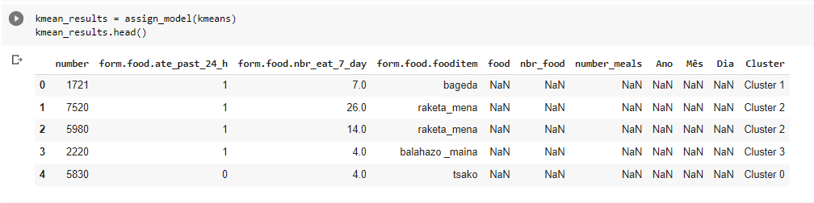

This function takes a trained model object and returns a plot on the dataset passed during setup stage. This function internally calls assign_model before generating a plot.

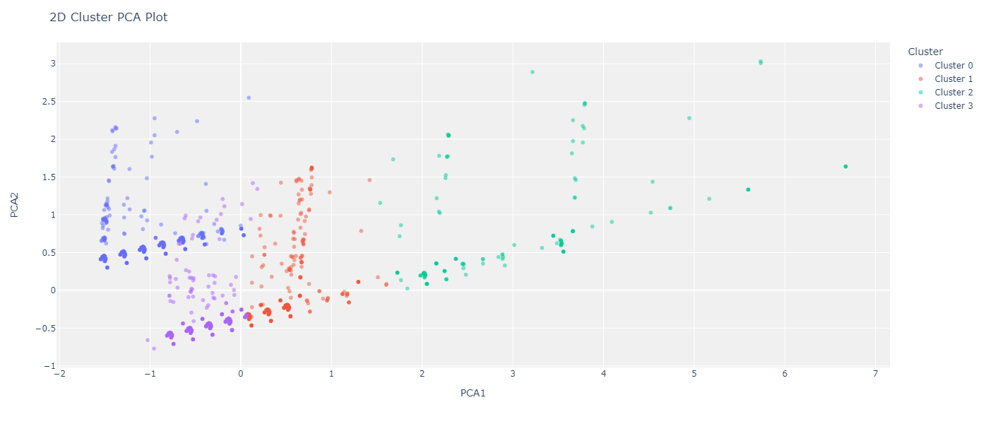

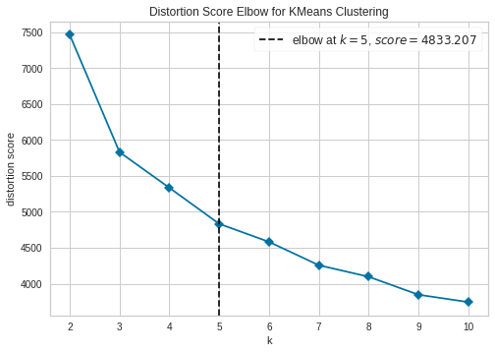

We can check the distribution of occurrences generated by cluster.

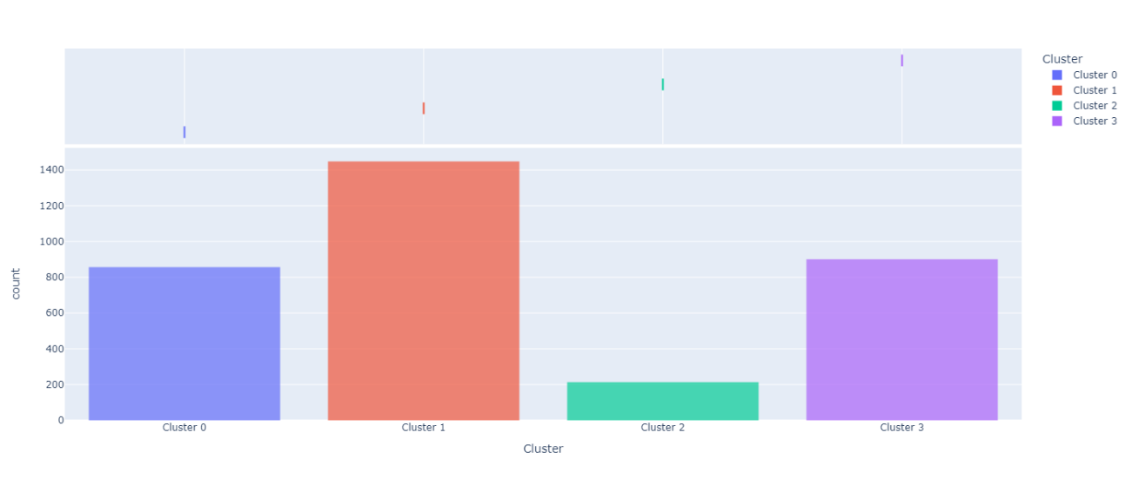

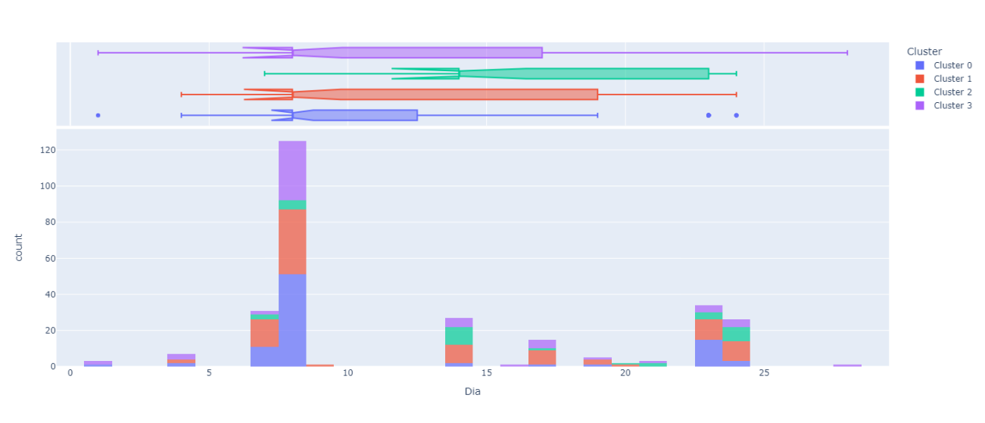

After these steps we perform the deployment of the cluster model that characterizes each group. This function deploys the transformation pipeline and trained model object for production use. The platform of deployment can be defined under the platform param along with the applicable authentication tokens which are passed as dictionary to the authentication param.

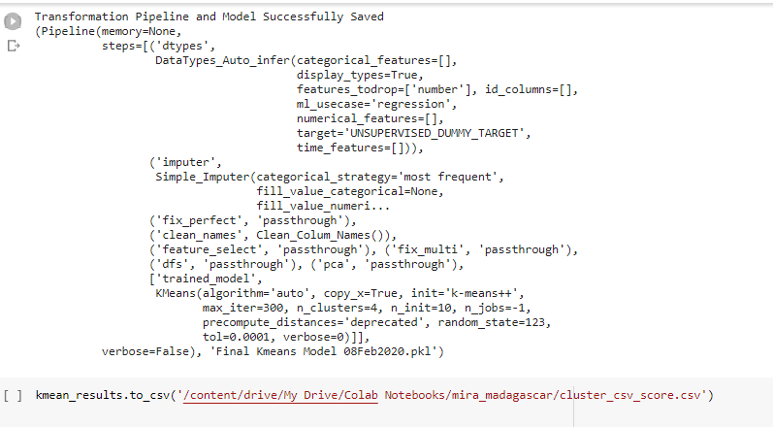

In this summary table we can see how clusters characterize the level of food security.

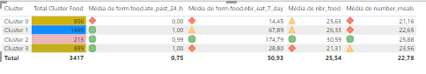

Cluster 1 – higher concentration of families, has a low level of food security, because it has low average food in the last 7 days, low number of meals and low diversification of items.

Cluster 3 – has a low level of food security, as it has low average food in the last 7 days, low number of meals and low diversification of items.

Cluster 0 – Higher risk of food insecurity because : has low level of food in the last 24 hours, has a low level of food security, because it has low average feeding in the last 7 days, low number of meals and low diversification of items.

Cluster 2 - Cluster with higher level of food security.

**Random Forest for Cluster Forecasting**

After creating the unsupervised model with cluster, it is time to perform the task of predicting the levels of food insecurity found. The first step for this task is to carry out the import of data and library defining the target to be predicted. This function initializes the environment in pycaret and creates the transformation pipeline to prepare the data for modeling and deployment. setup() must called before executing any other function in pycaret. It takes two mandatory parameters: dataframe {array-like, sparse matrix} and name of the target column. All other parameters are optional.

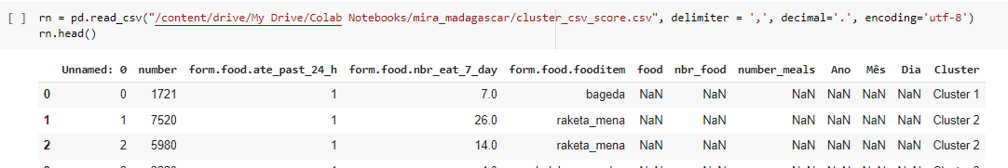

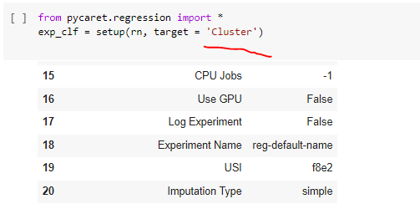

This function uses all models in the model library and scores them using Stratified Cross Validation. The output prints a score grid that shows Accuracy, AUC, Recall, Precision, F1 and Kappa by fold (default CV = 10 Folds) of all the available models in the model library.

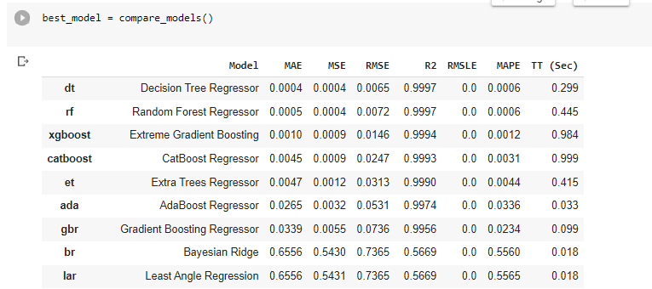

This function creates a model and scores it using Stratified Cross Validation. The output prints a score grid that shows Accuracy, AUC, Recall, Precision, F1 and Kappa by fold (default = 10 Fold). This function returns a trained model object. setup() function must be called before using create_model().

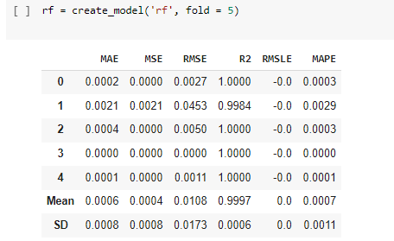

This function takes a trained model object and returns a plot based on the test / hold-out set. The process may require the model to be re-trained in certain cases. See list of plots supported below. Model must be created using create_model() or tune_model().

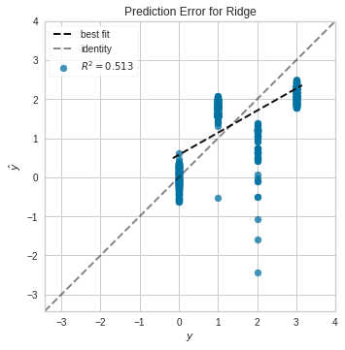

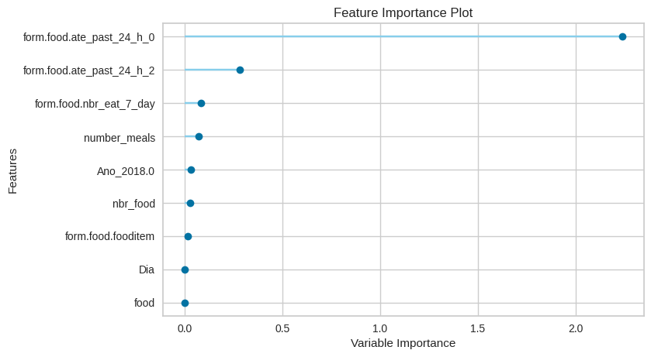

This function takes a trained model object and returns an interpretation plot based on the test / hold-out set. It only supports tree based algorithms. This function is implemented based on the SHAP (SHapley Additive exPlanations), which is a unified approach to explain the output of any machine learning model. SHAP connects game theory with local explanations.

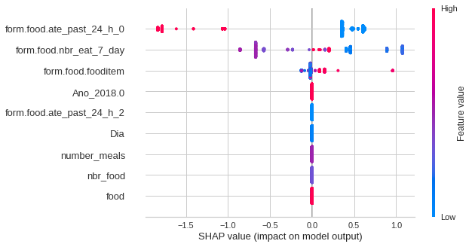

This function saves the transformation pipeline and trained model object into the current active directory as a pickle file for later use.

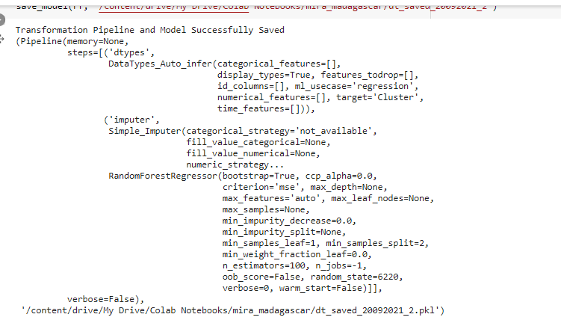

After deploying the classification model, you can create an interface for model consumption. For this, the flask library and an HTML page were used. This step is not required.

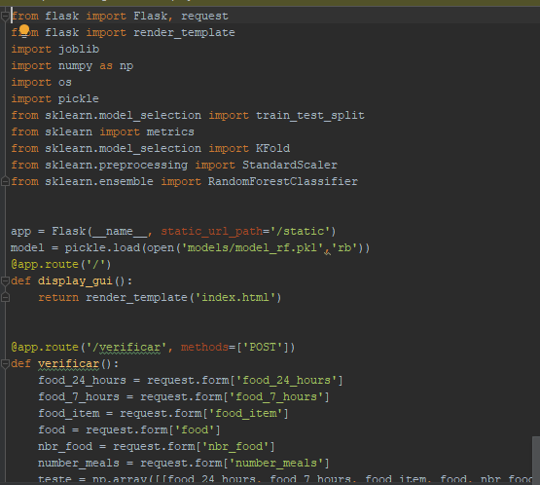

**Interface**

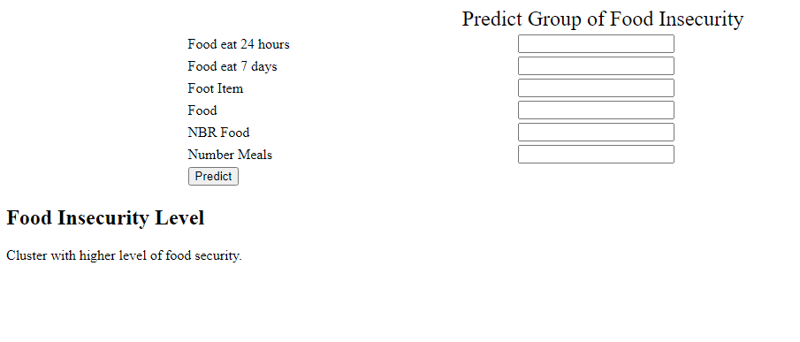

To perform the analysis we used the Madagascar database, we downloaded the workspace of the commcare,with the following regions as the object of analysis.

Figure 1 - Commcare Base Sheet

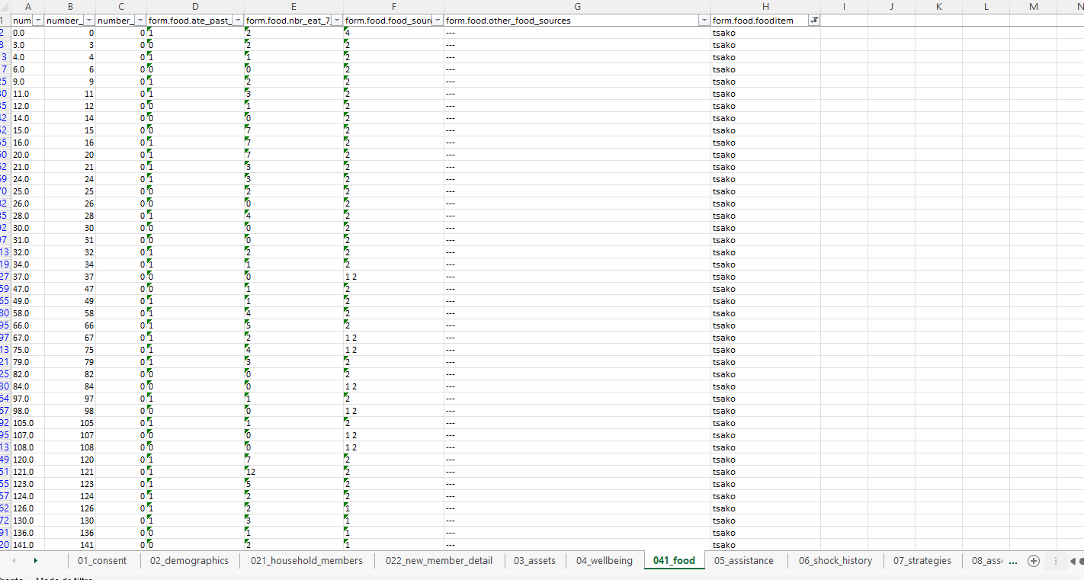

Figure 2 - Worked communities.

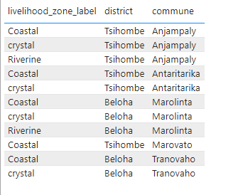

We constructed a dataset with the frequencies having performed the one hot encoding and generation of the frequencies of each variable.

Figure 3 - Frequencies of worked variables

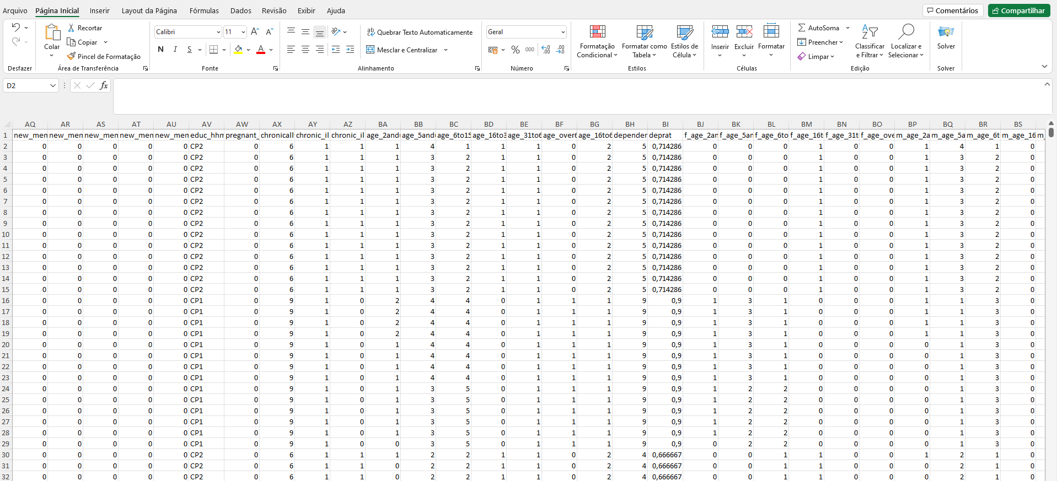

Construction of HDDS



**Data Model**

After the preparatory steps we passed the construction of a cluster-based unsupervised machine learning model for identification at the level of diversification and score of the HHDS indicator. For this we use python, sklearn and pycaret as libraries for model development. The first step was to import the previously generated dataset.

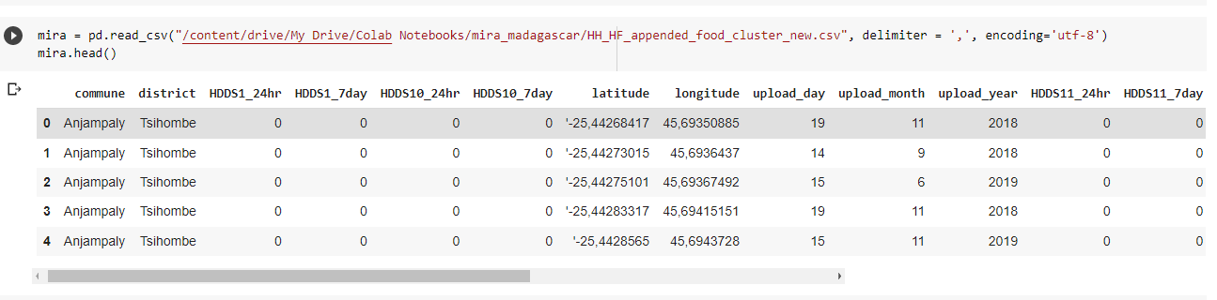

Following the development of the model we performed the configuration of the data in the pycaret library and creation of the cluster model with the library kmeans.

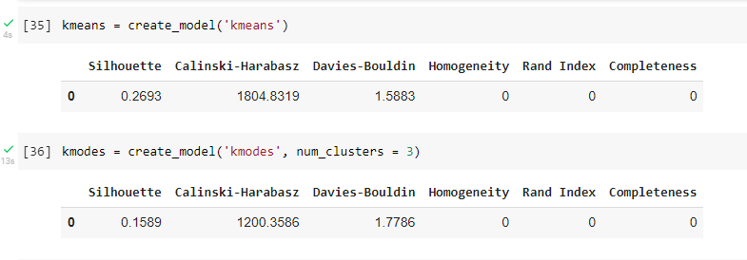

After these preparatory steps, we carried out the study and took as a prerequisite the DD Indicator Construction to perform the creation of a cluster model that can characterize the level of diversification of the diet based on the indicators available. The groups were characteristic zed by analyzing the variables HHDSs from 1 to 11 in the 24-hour and 7-day indicators, analyzing the mean frequency of variable per group.

cluster 0 - Poor: is the group with the lowest level of diversification in food. The diet is based on cereals with some inclusion of fish protein.

cluster 1 - Borderline: is the group with average level of diversification in food. Food is based on roots-tubers, vegetables and fruits.

cluster 2 - Good : is the group with good level of diversification in food. The food is based on cereals, roots-tubers, vegetables, fruits, vegetables-nuts, fish-seafood and meat-poultry.

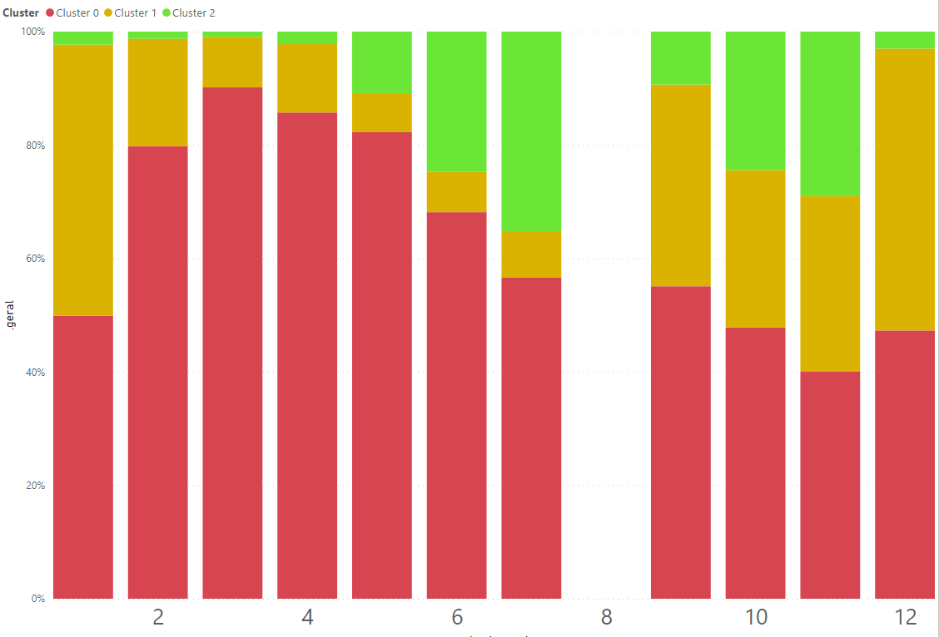

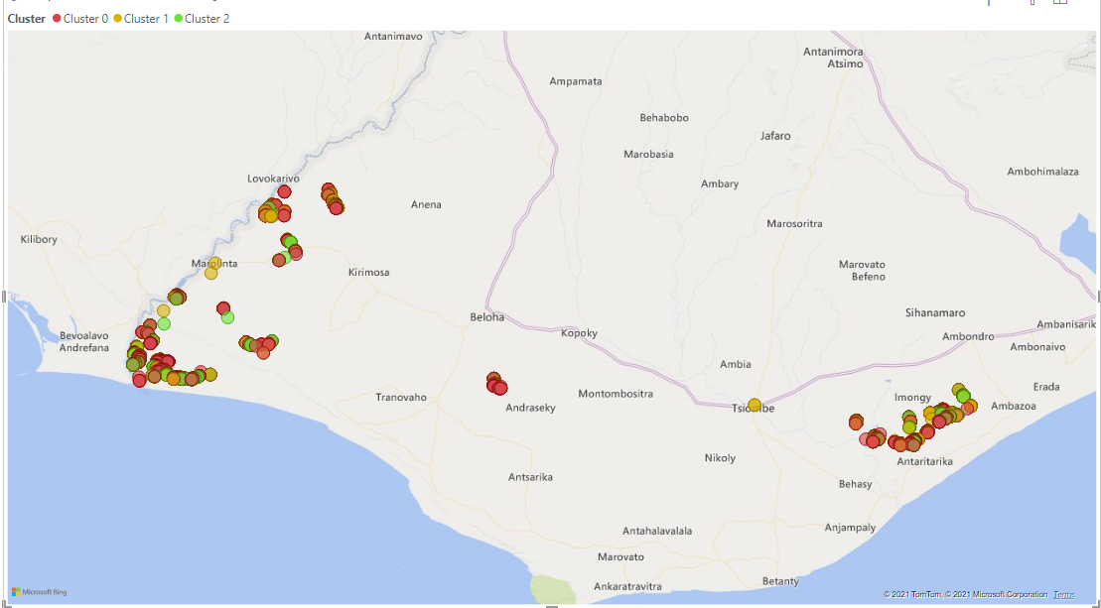

Summary Table of Poor Group Averages:

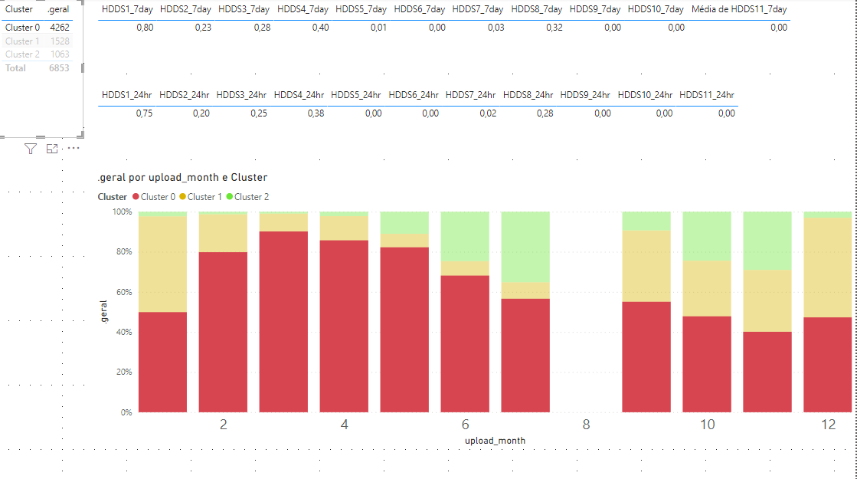

Summary Table of Borderline Group Averages:

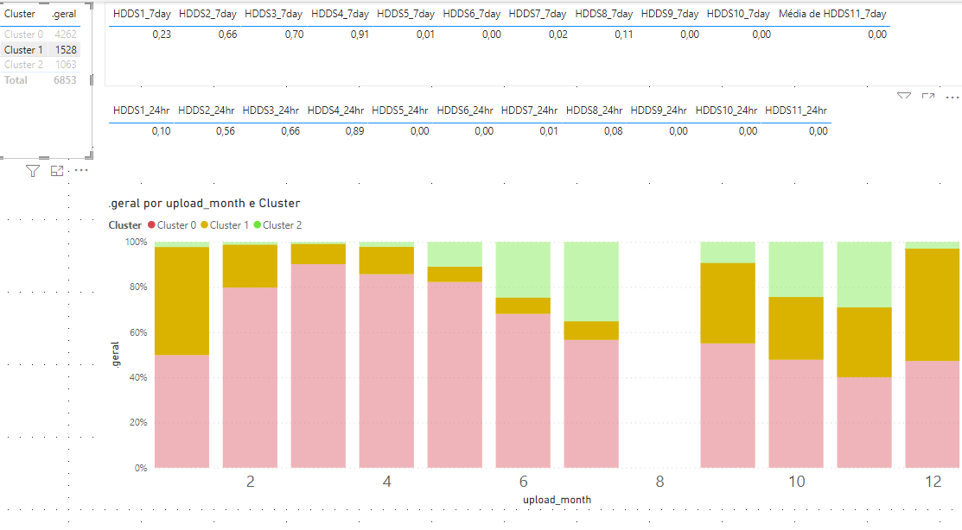

Summary Table of GoodGroup Averages:

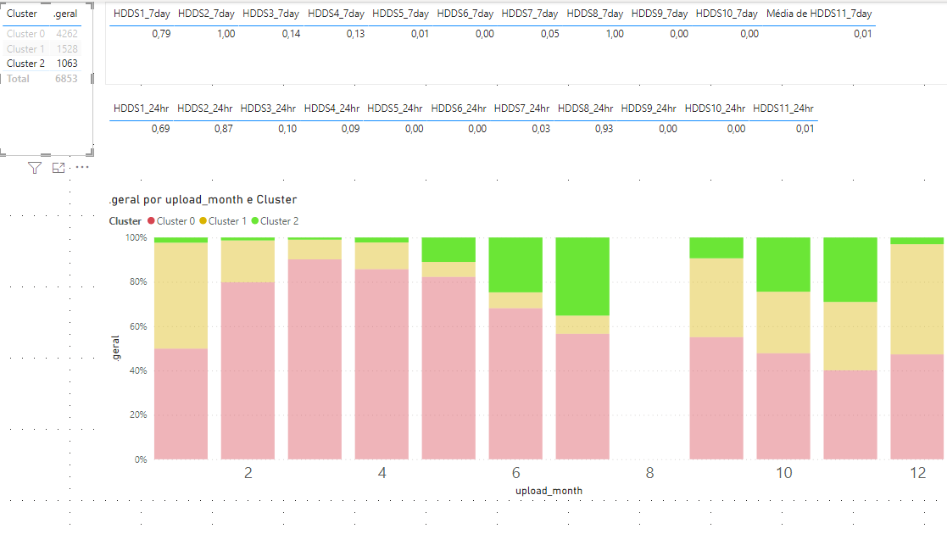

## **How to maintain the model**

1. A skilled software developer is required to maintain the code.
2. The domain expert is required to interpret the results and help in taking better business decisions.

## **Scale-up Challenges: Madagascar MIRA dataset case study**

* + - 1. The data was not correctly exported from CommCare. High Frequency data of Madagascar was having 700 odd variables. When exported correctly from CommCare, it had only 270 odd variables. Please refer Part 3 in the document to correctly export data from CommCare.
      2. Variable names did not follow any good naming standards.
      3. The variables collected differed in every module when compared to Malawi. Suggest following the standard way to collect the data and the same variables for every country program to ease the scaling.